# Planning and design

## Initial project backlog

Just the initial setup to demonstrate to bi-weekly reports and have everything organised in one convenient location. Screenshot for bi-weekly report 2 (30th Oct 2020) below.

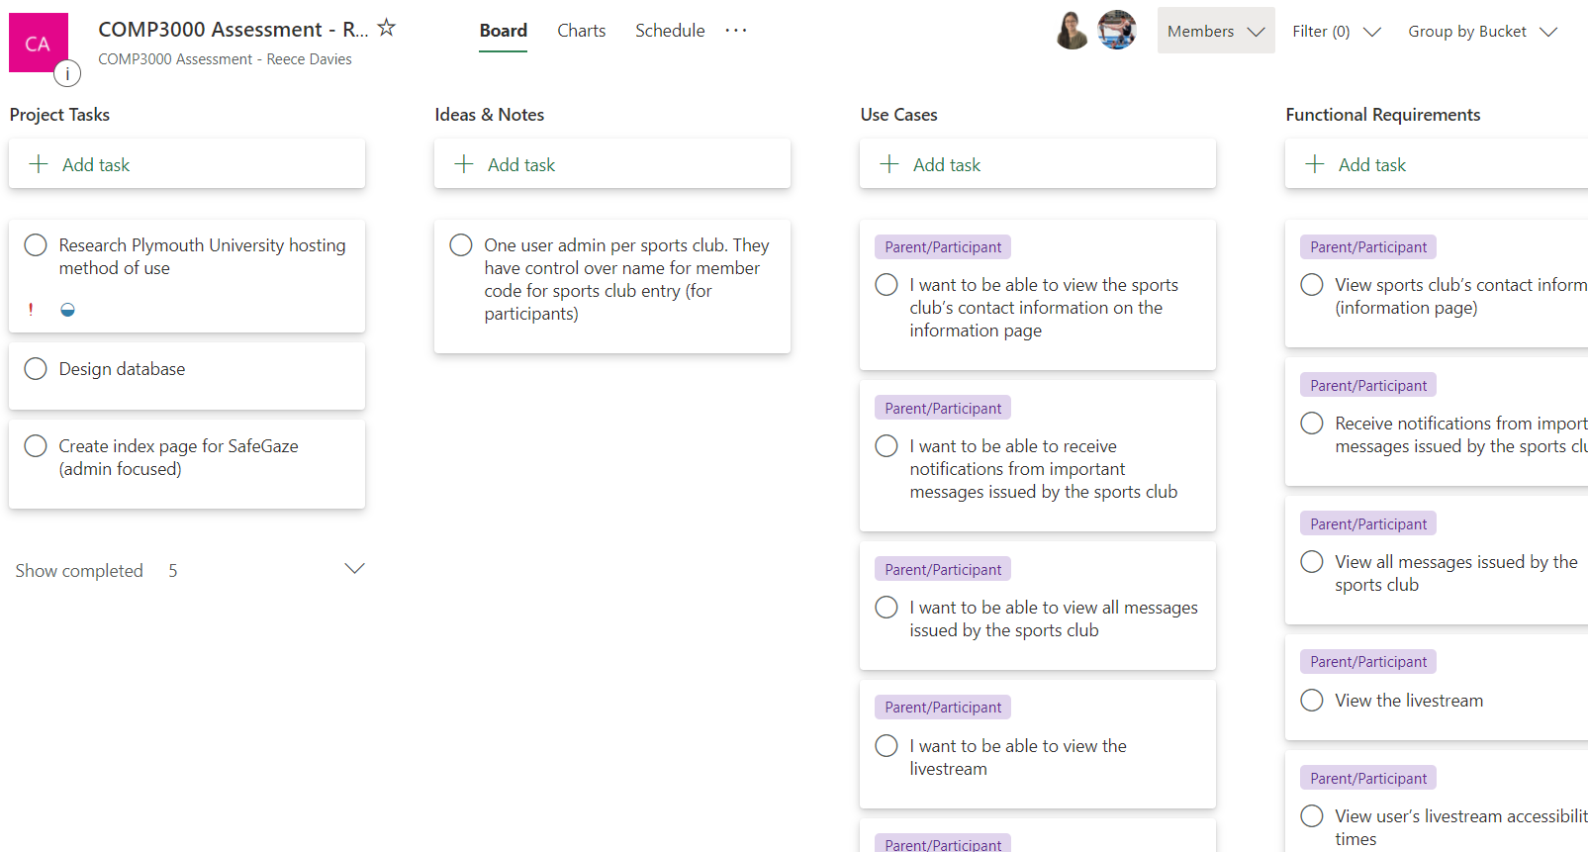

## Initial database relationship design

A few amendments were made but this is the initial design.

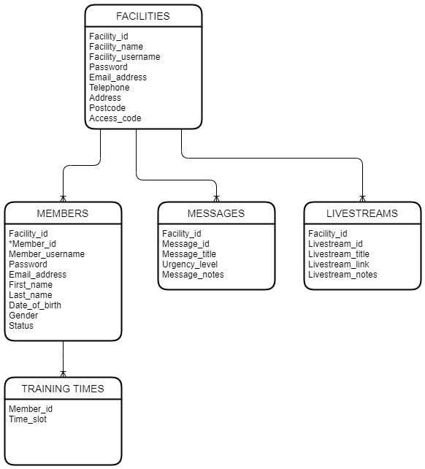

# Start of development

## Initial index page with login functionality

When user is NOT logged in. Screenshots taken 26th Nov 2020.

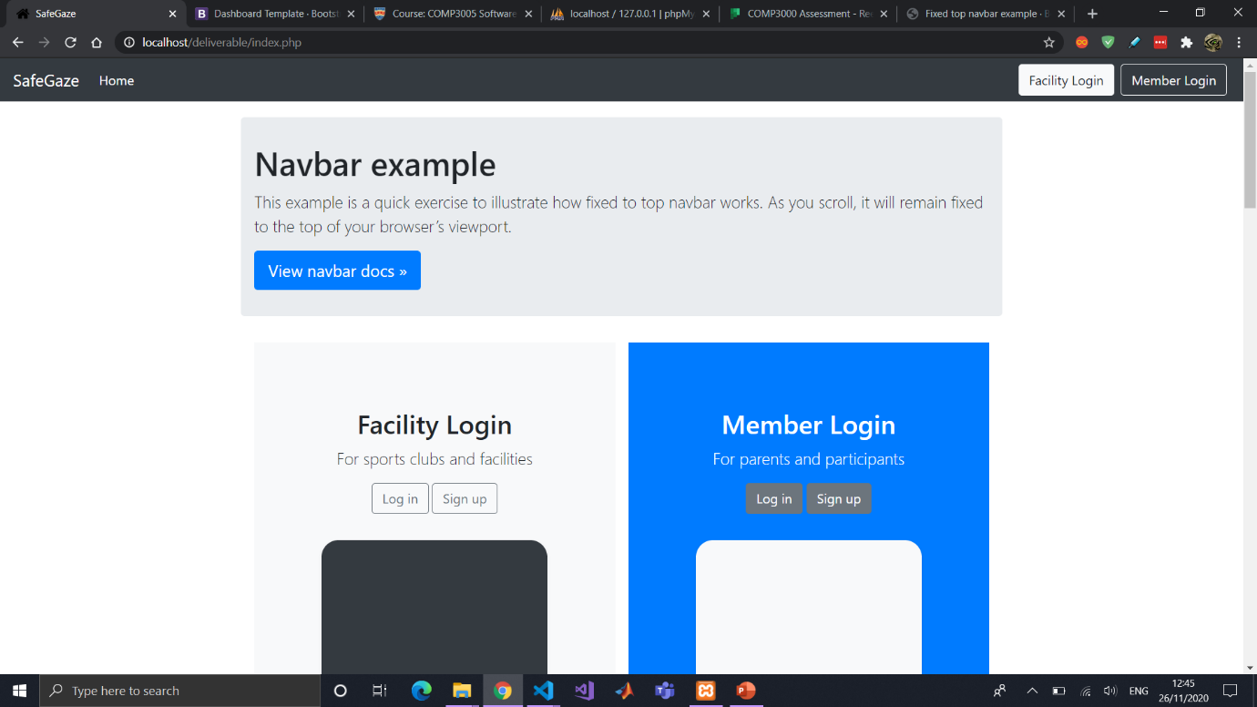

When user IS logged into facility account.

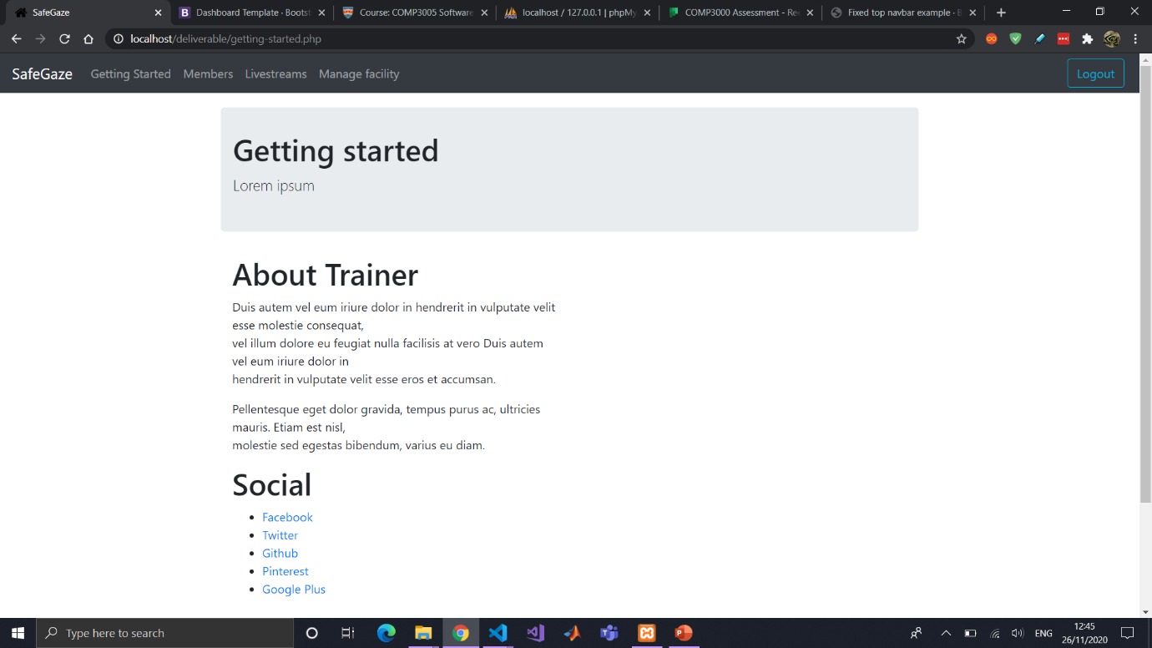

## Facility login page after amendments to facility styling

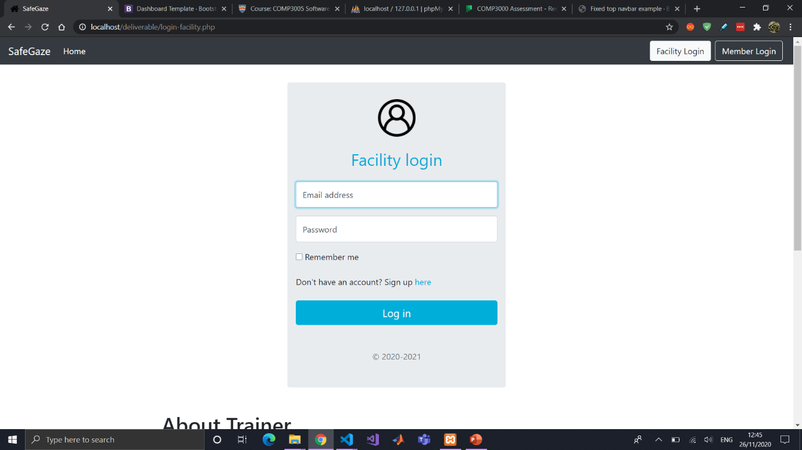

## Facility members management page(s) initial setup

Before making amendments/deciding which is the best approach for making the content tables.

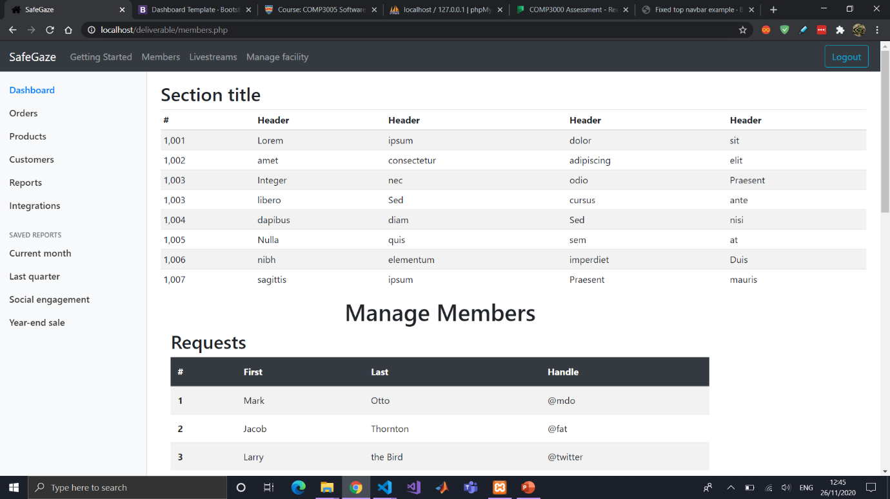

After deciding for the content table style + changing the style of the side navigation panel along with links to each page. 27th Nov 2020.

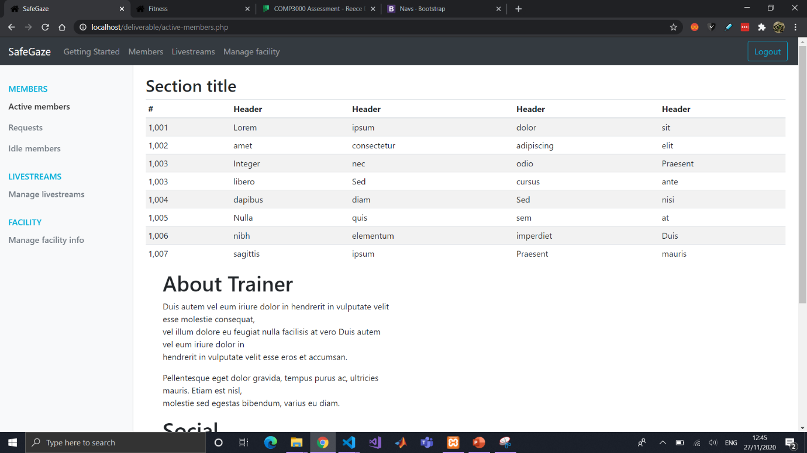

Changing the style to confine to devices with smaller screens + allowing for the side navigation panel to be as a dropdown menu.

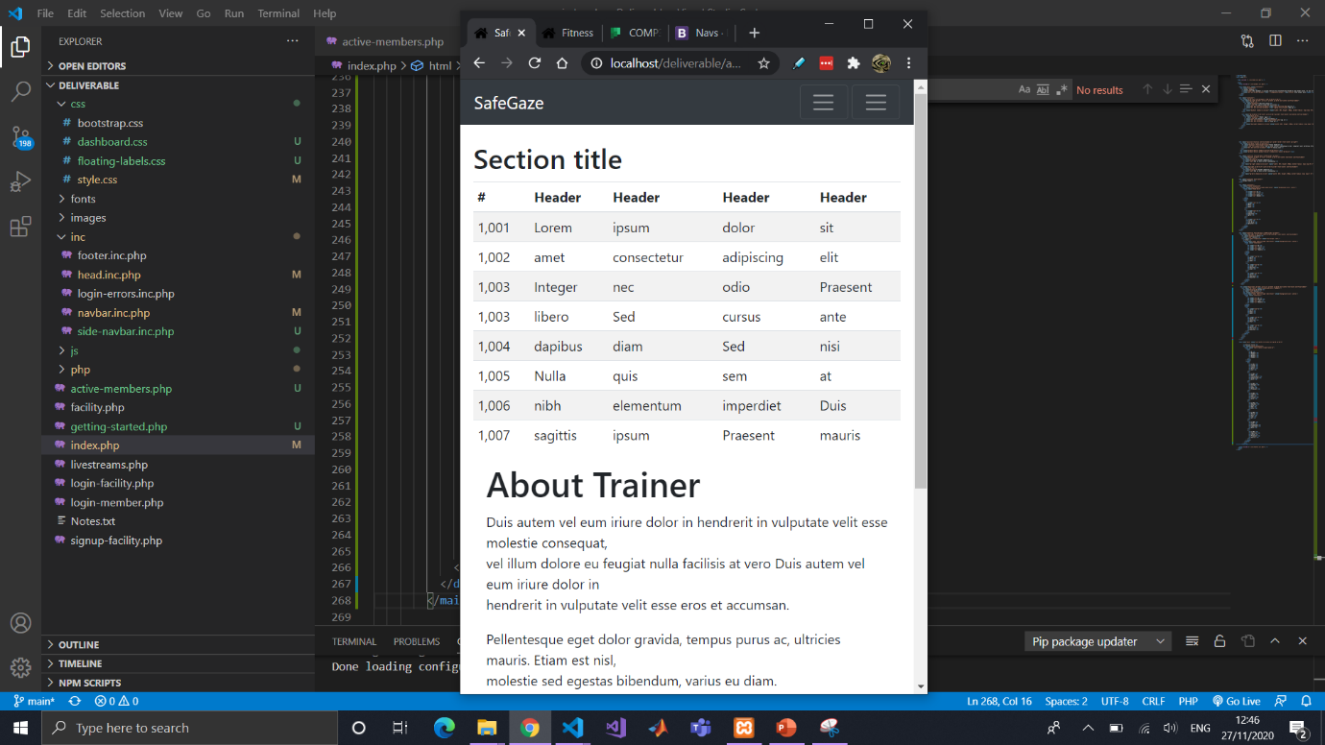

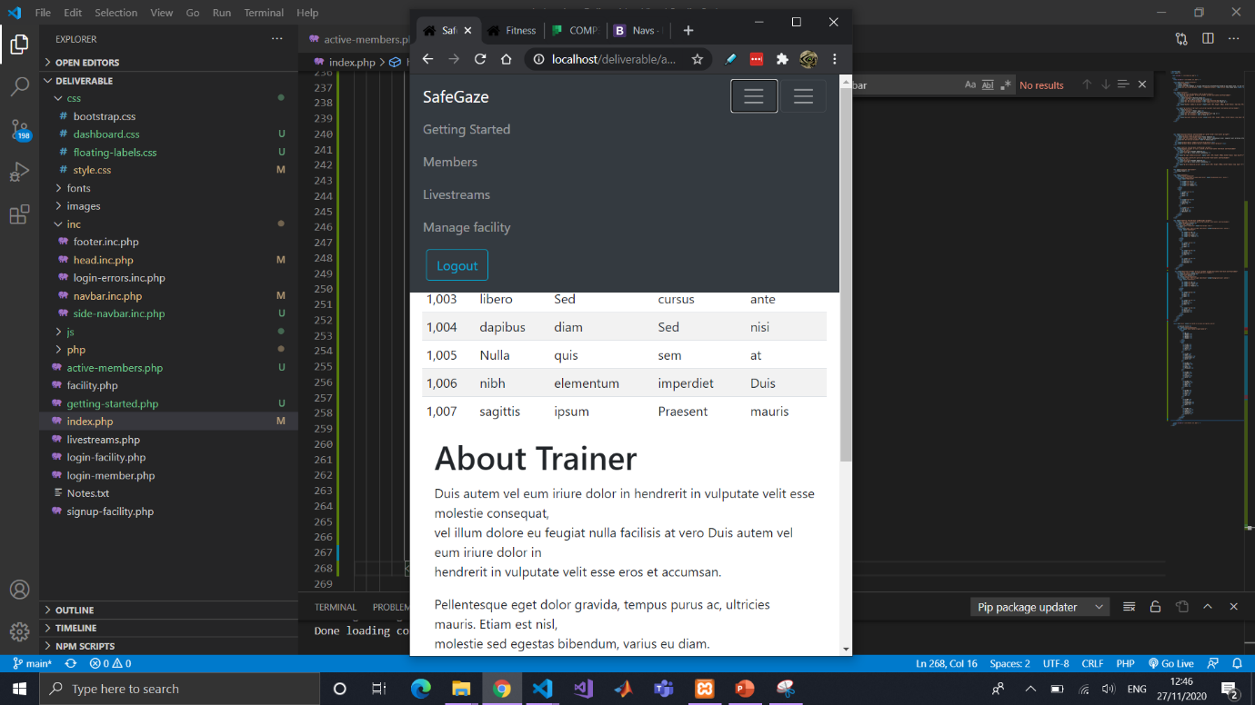

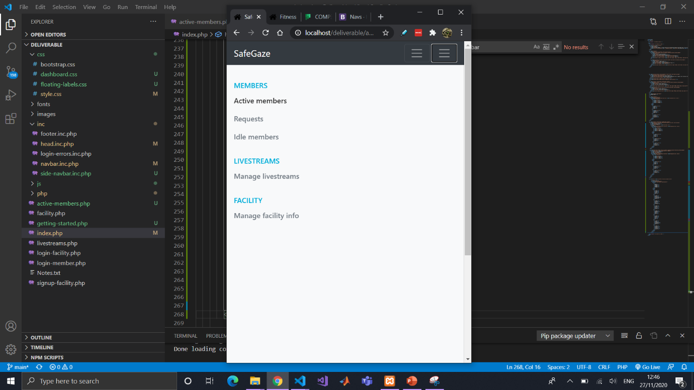

## Backlog updated for different sprints

Adjusting the backlog tasks to be more organised for all the tasks related to functional requirements. Screenshot taken 11th Dec 2020.

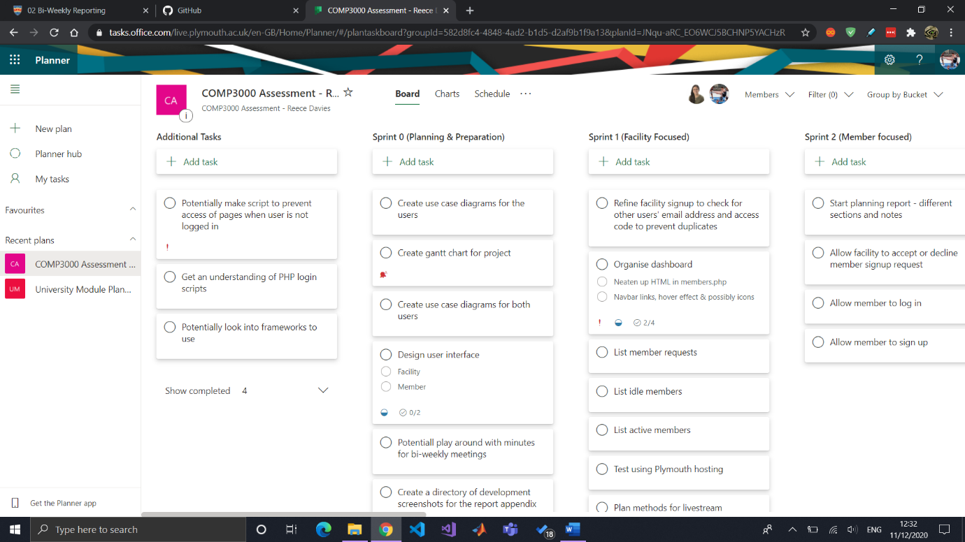

## Initial member management system

Works with database; buttons have been implemented and when the user clicks on it, a JavaScript function is executed.

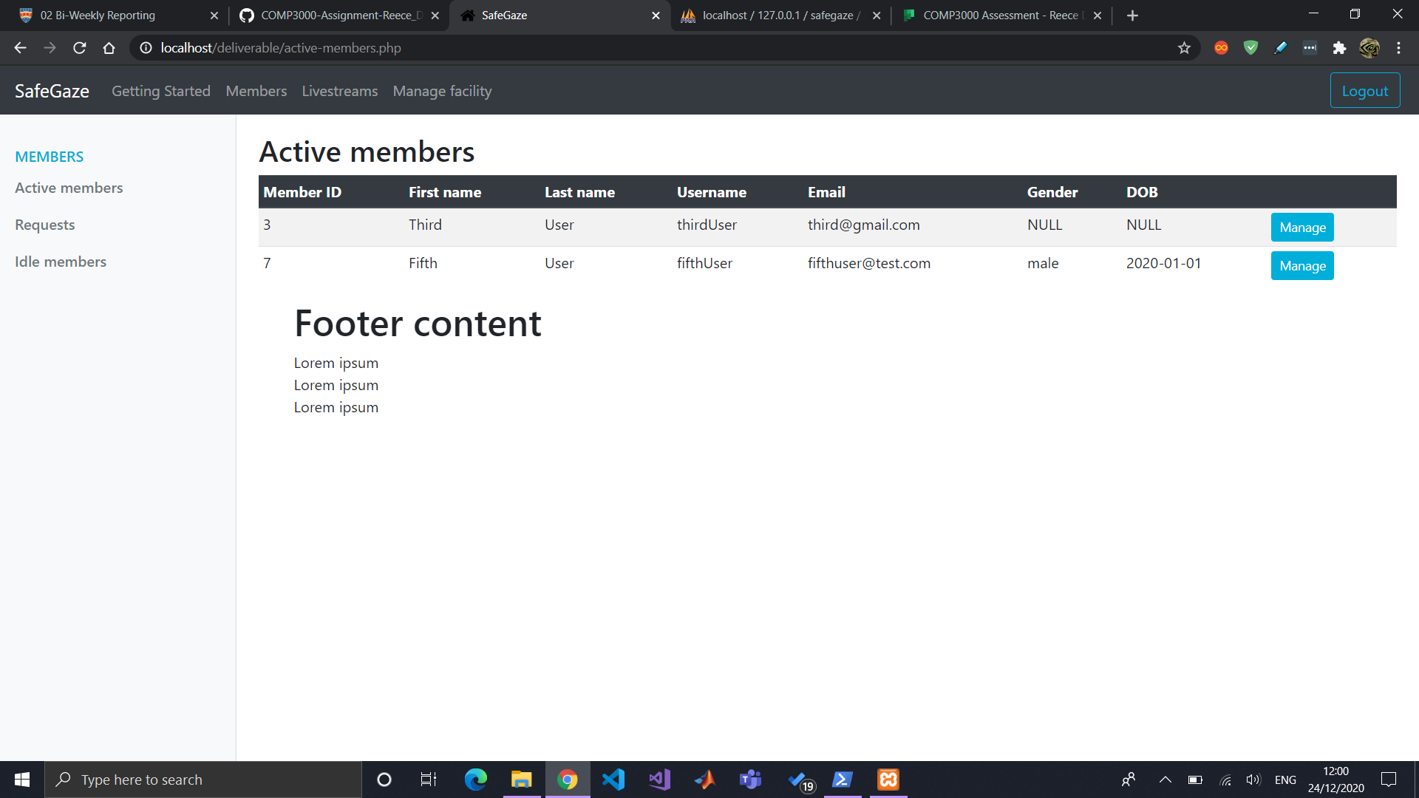

Works with database and functions will accept or decline a user.

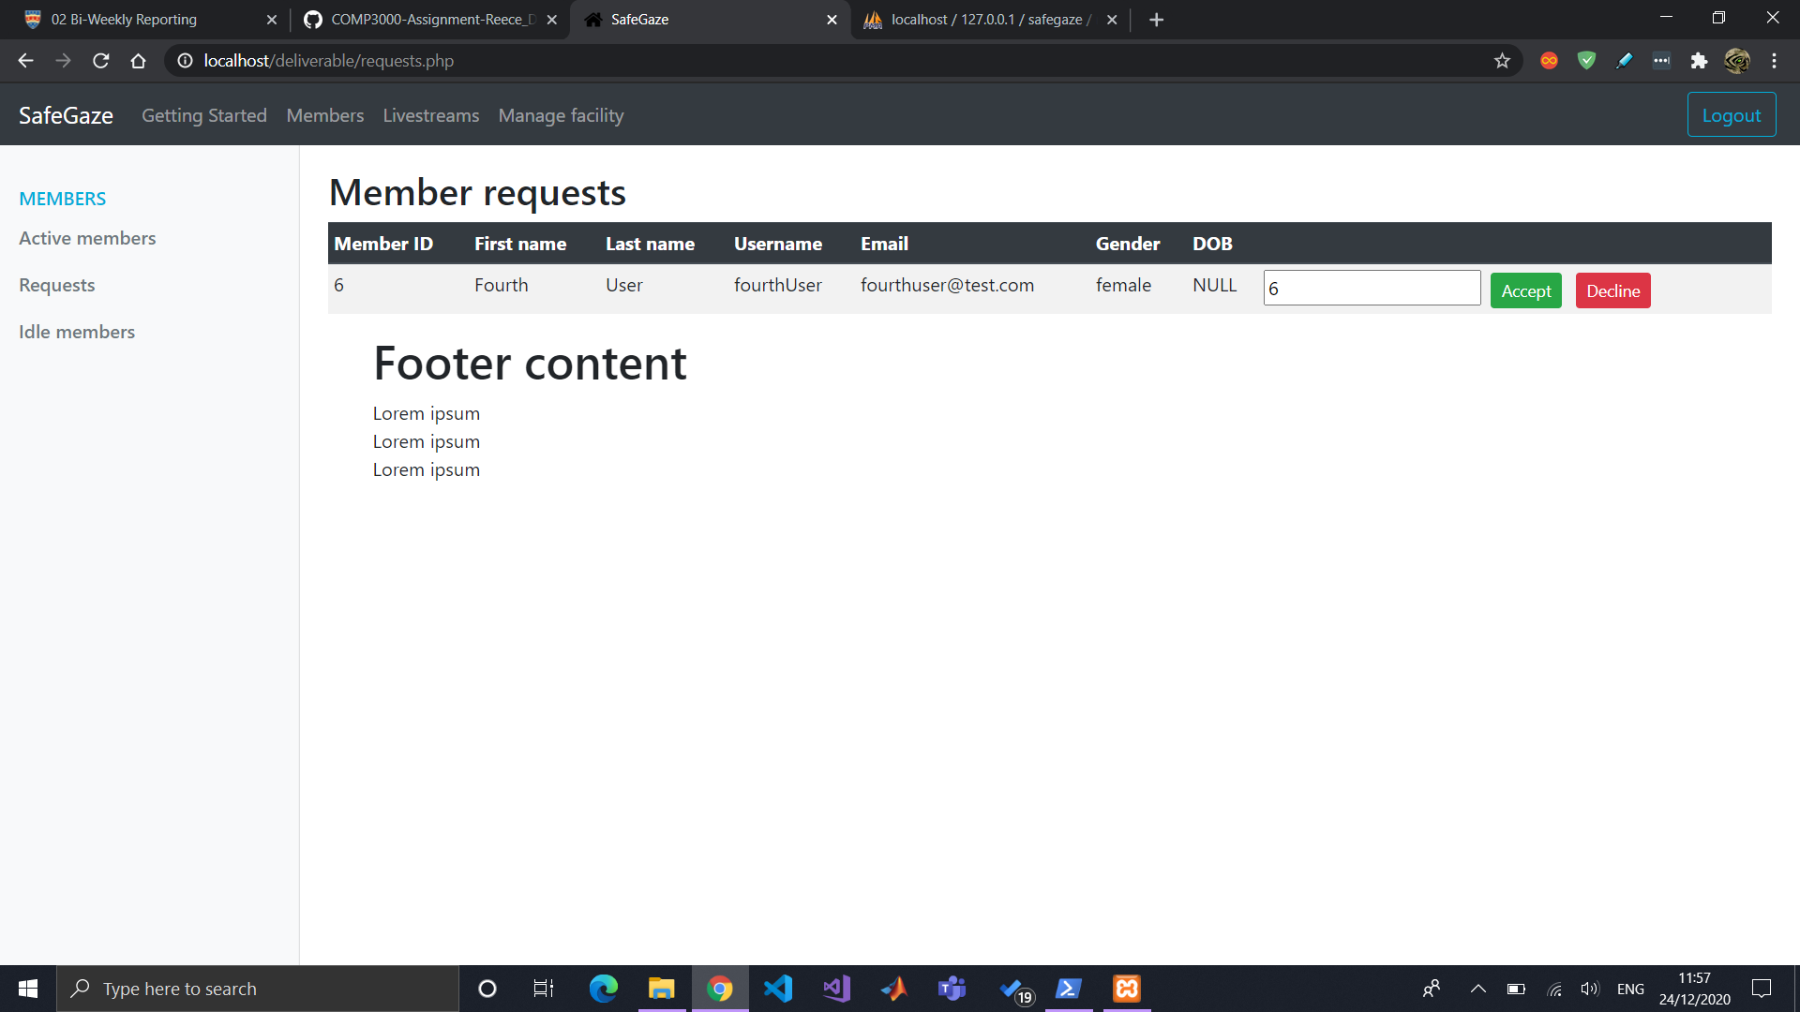

Idle members and its database values counterpart.

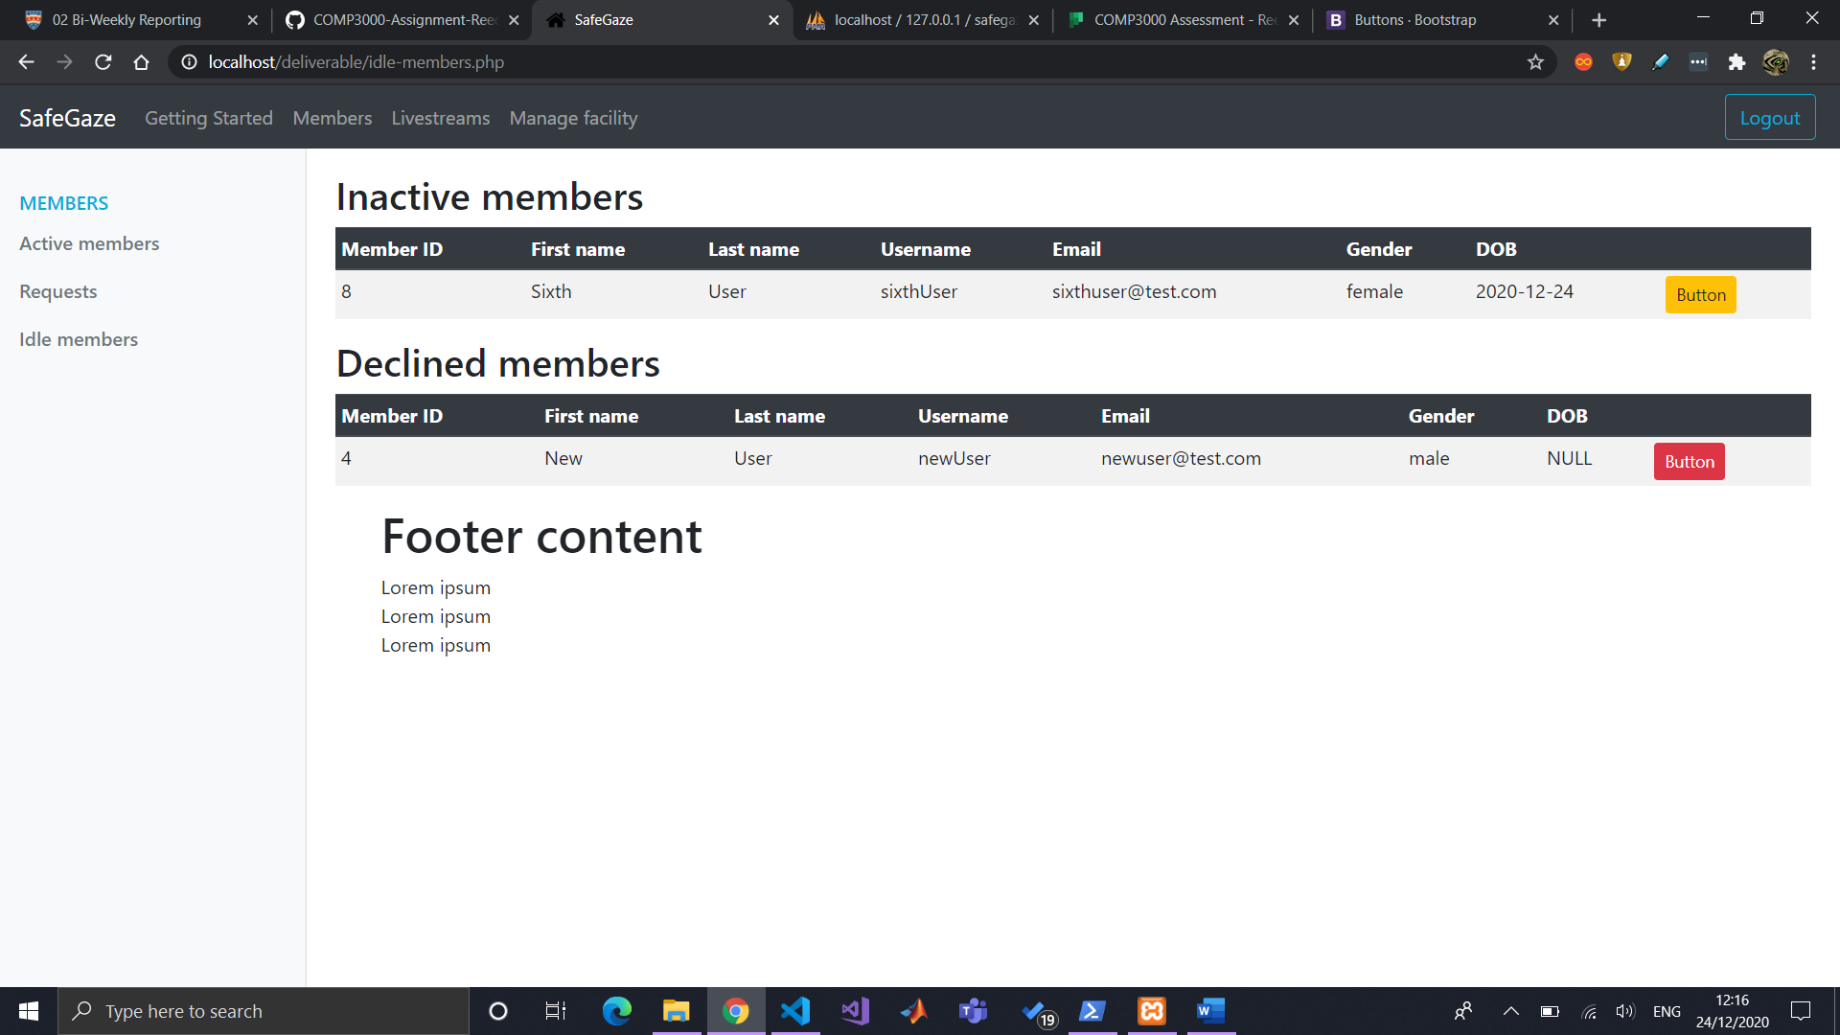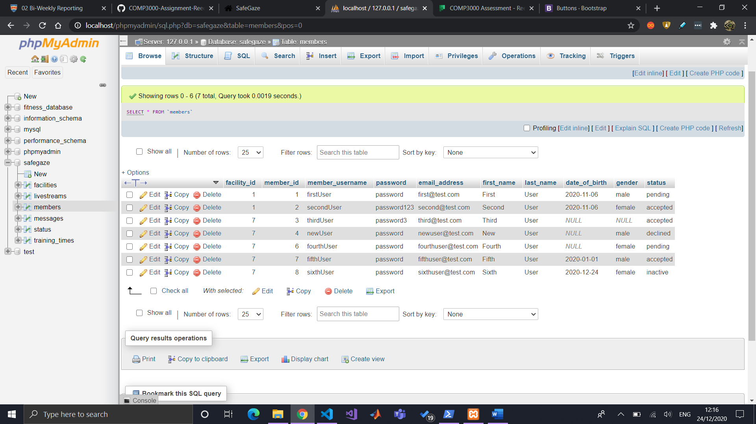

Manage a member’s status and times

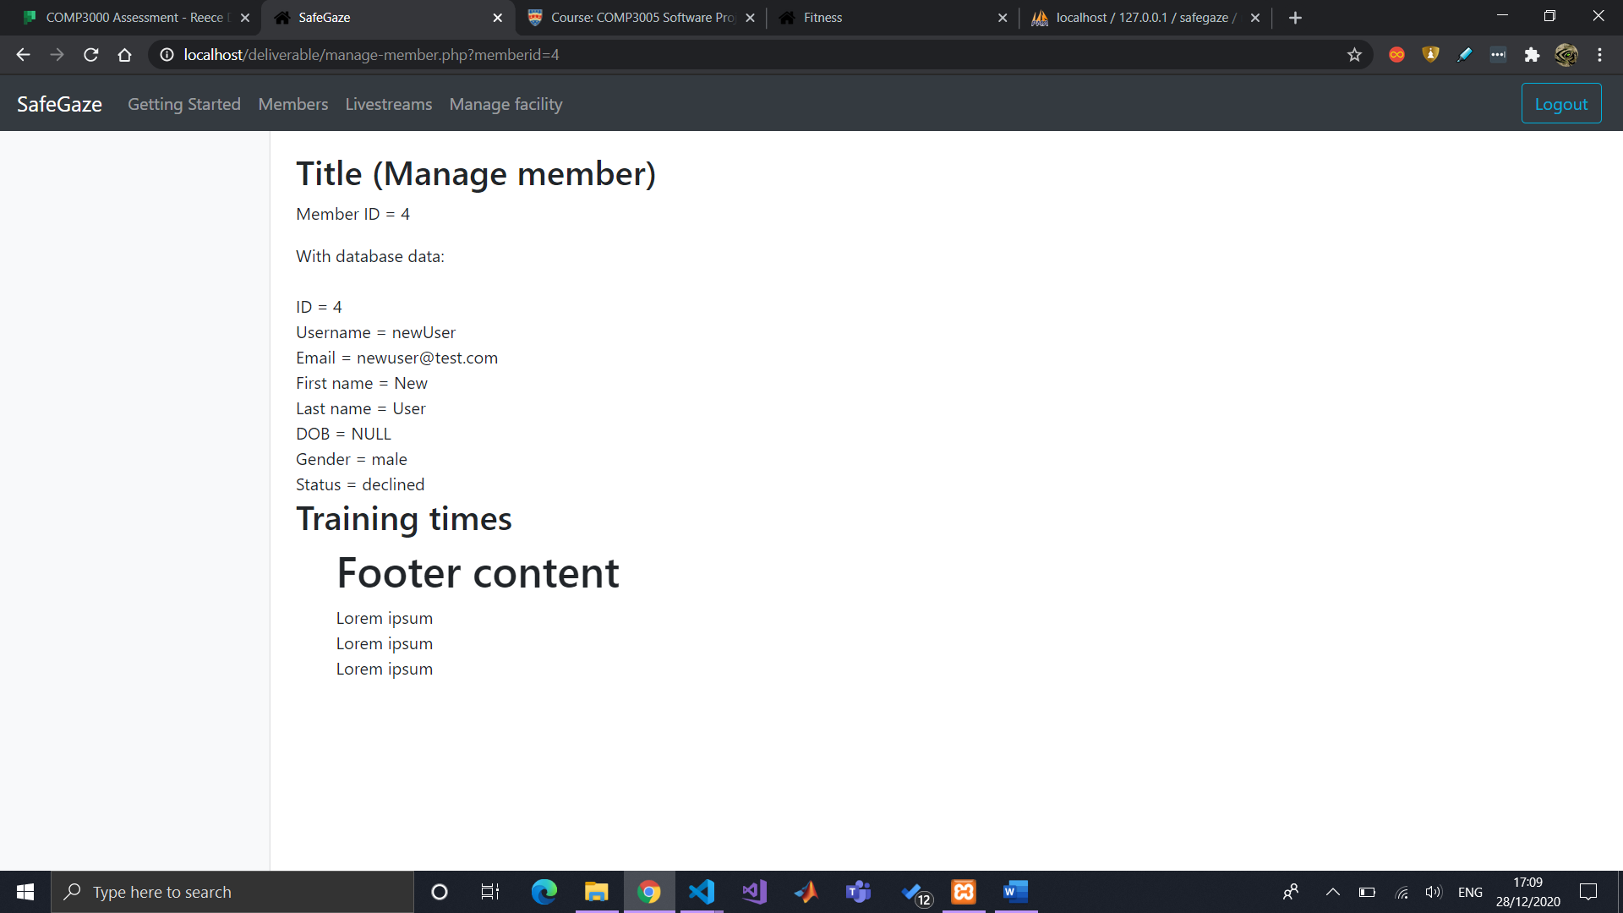

After some tweaking to make it editable.

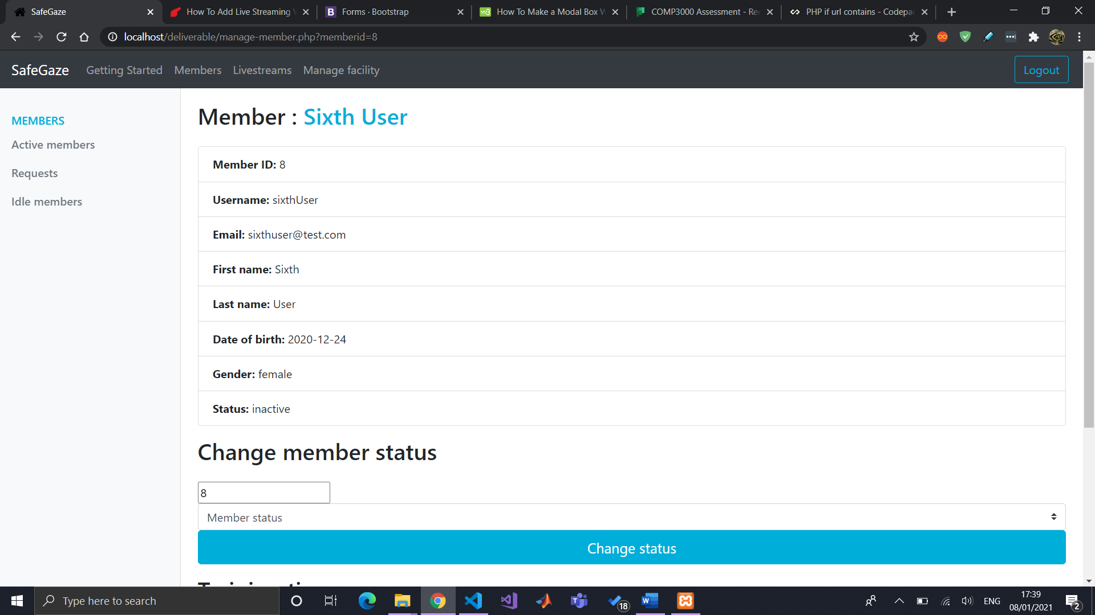

Managing a member’s training times (updates table if already exists) (still needs to list the member’s training times for facility user’s better understanding).

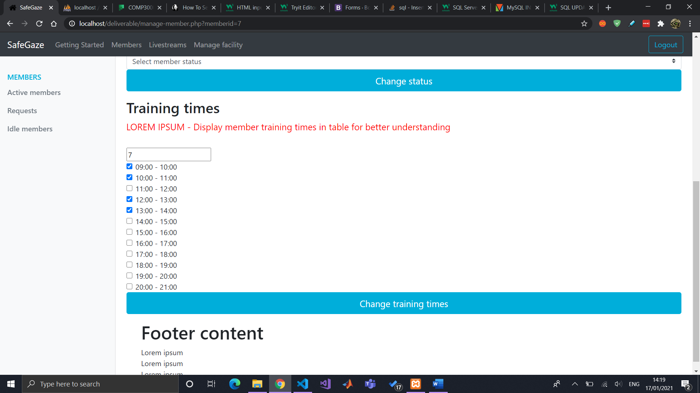

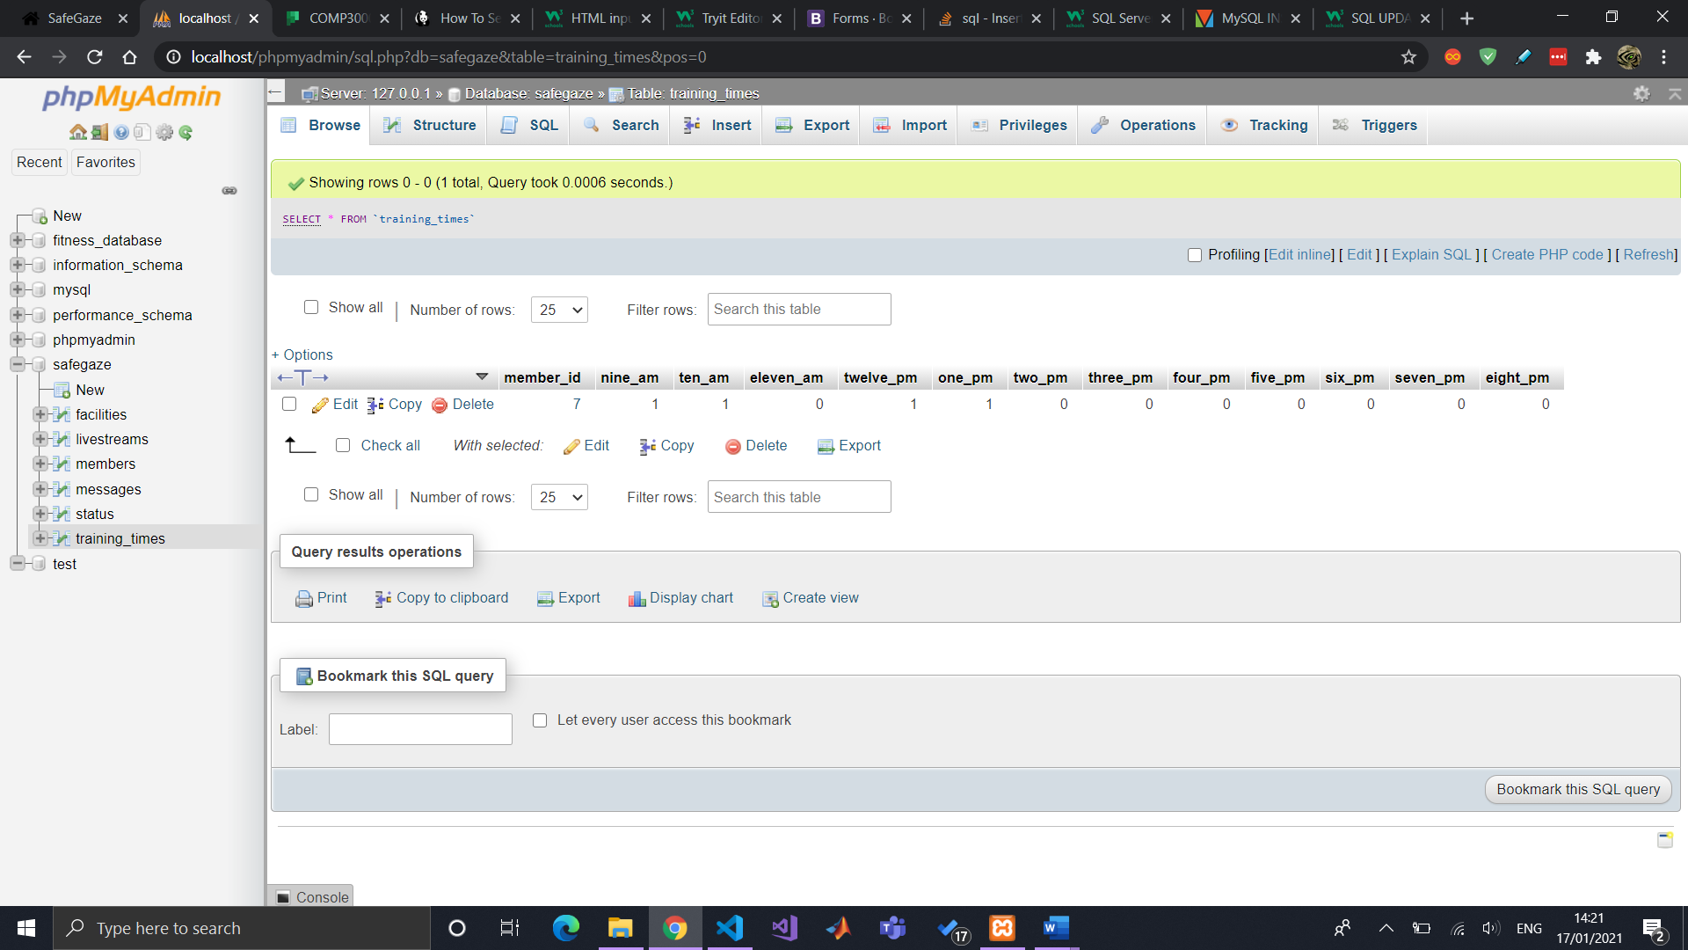

Manage member page now fully functional (might change styling in the future)

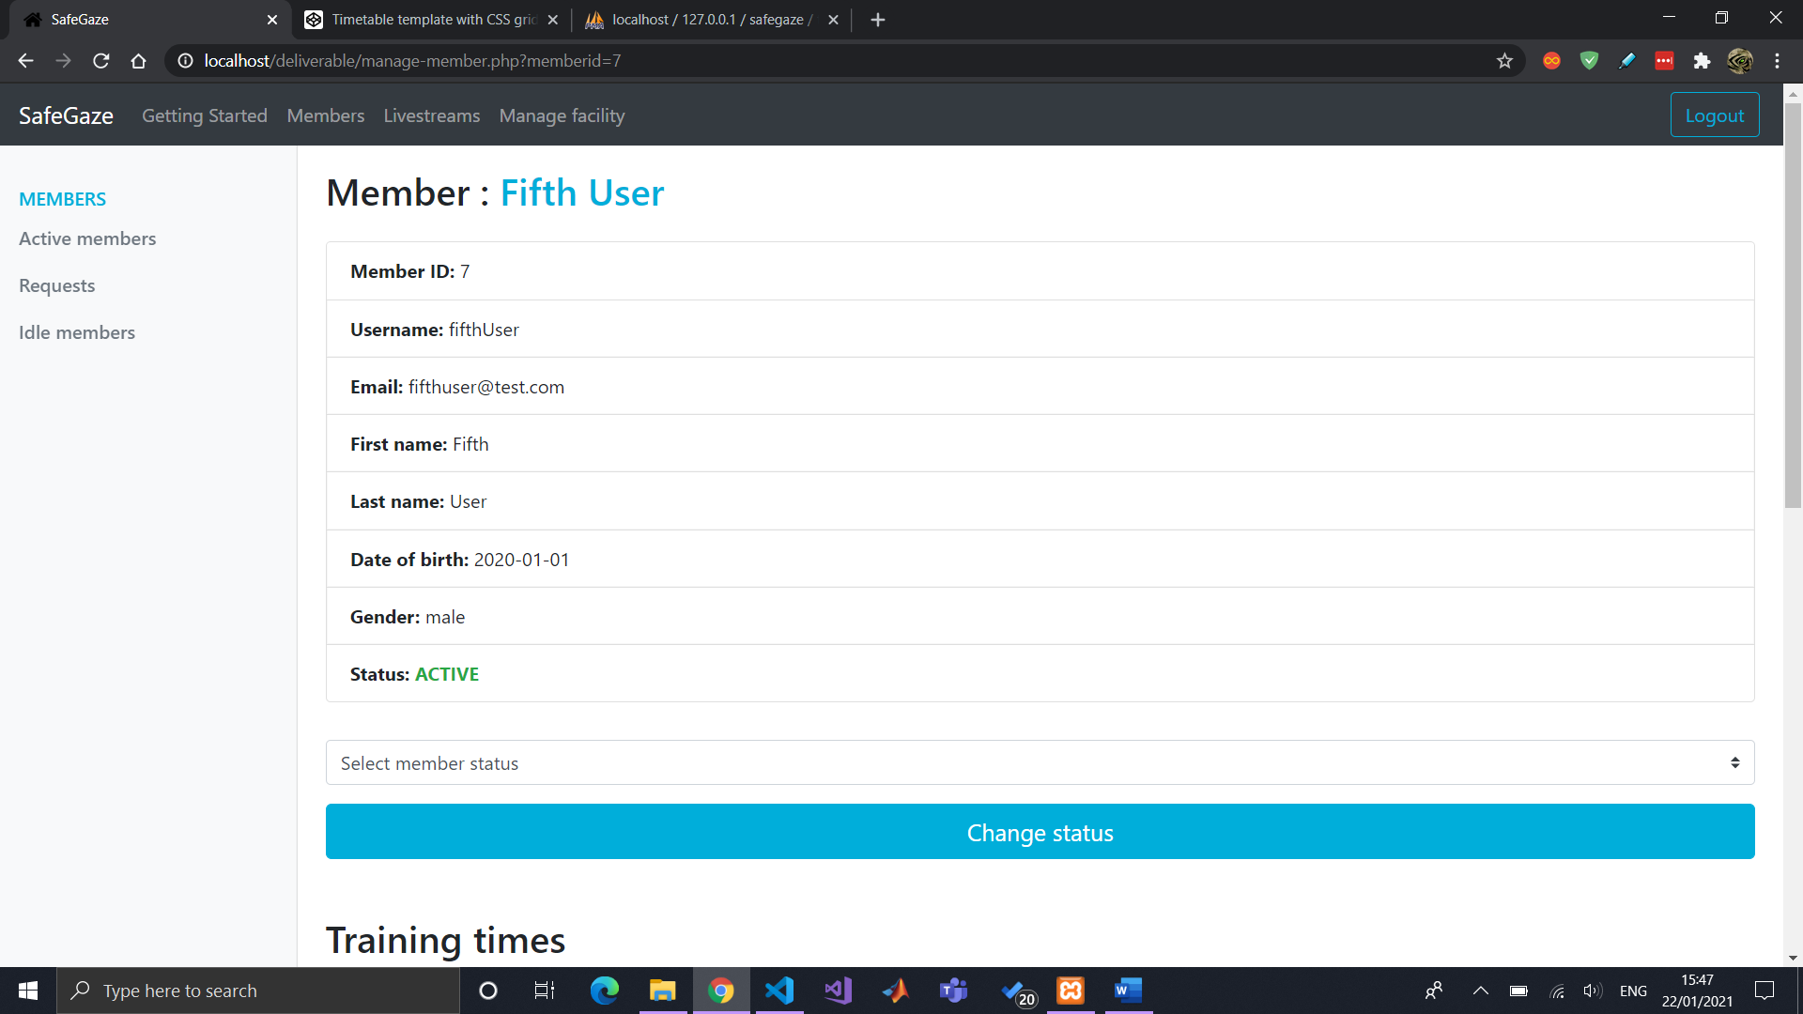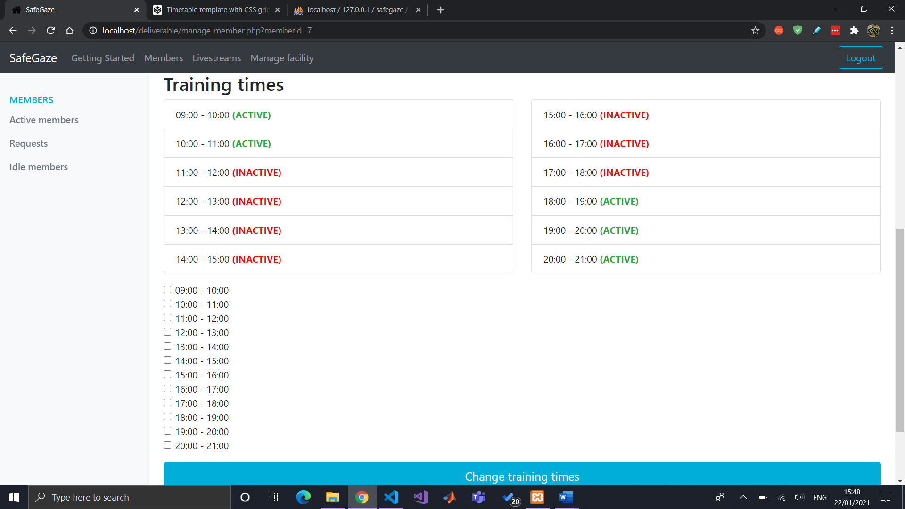

## Livestreaming

Can now connect the camera to the laptop (with an internet connection) by using the capture card.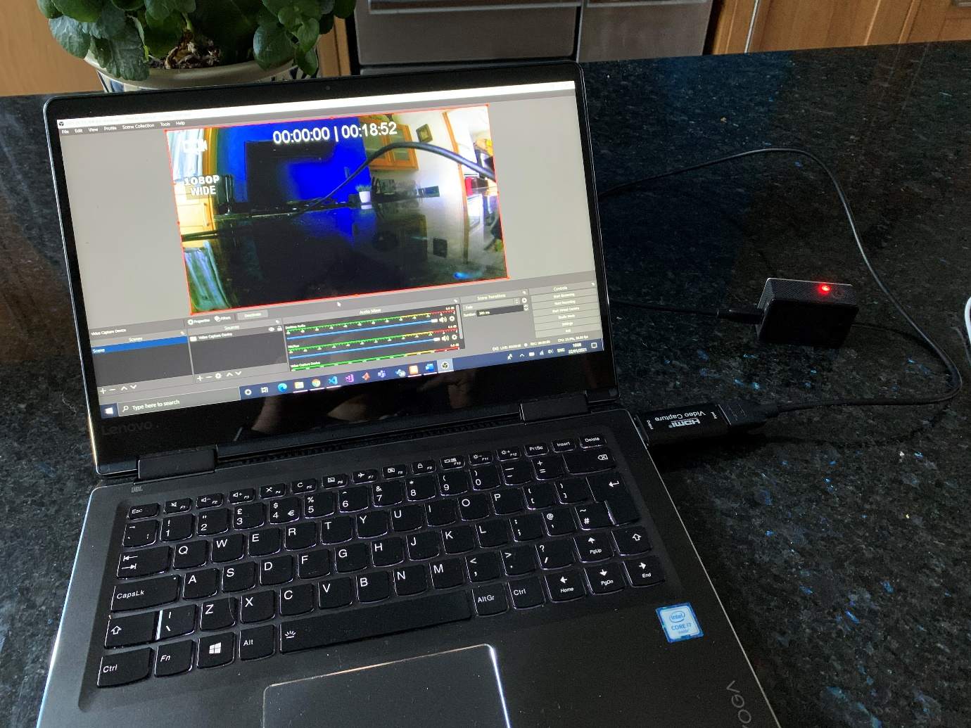

A start on managing livestreams

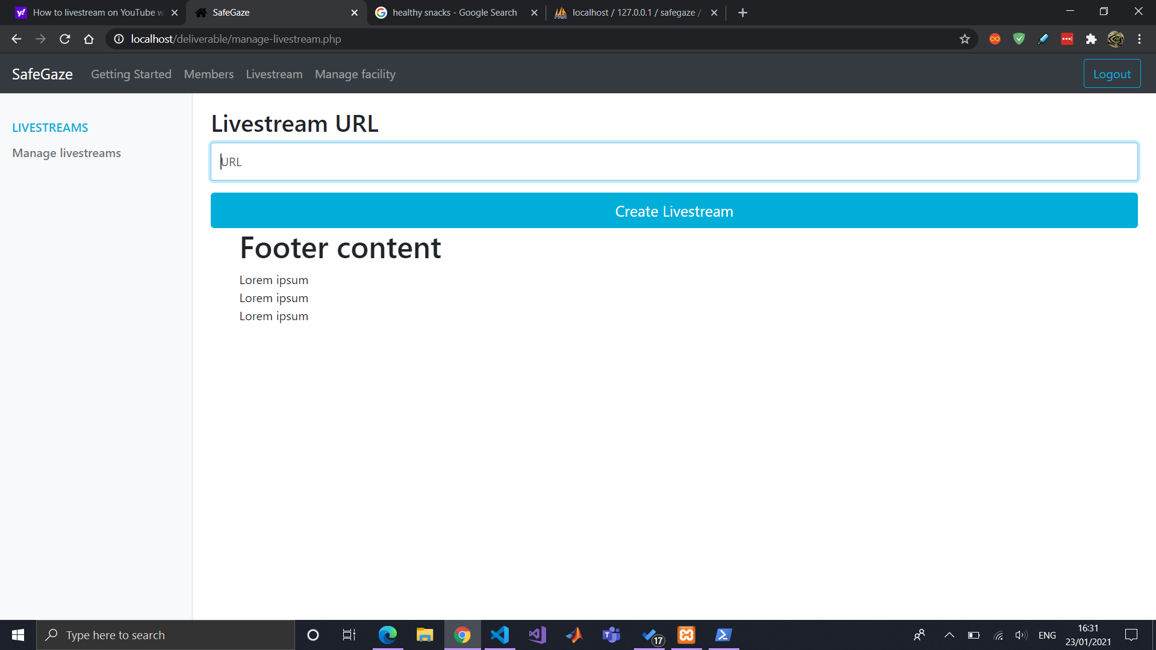

Initial livestream page (with access time checks) (YouTube oriented)

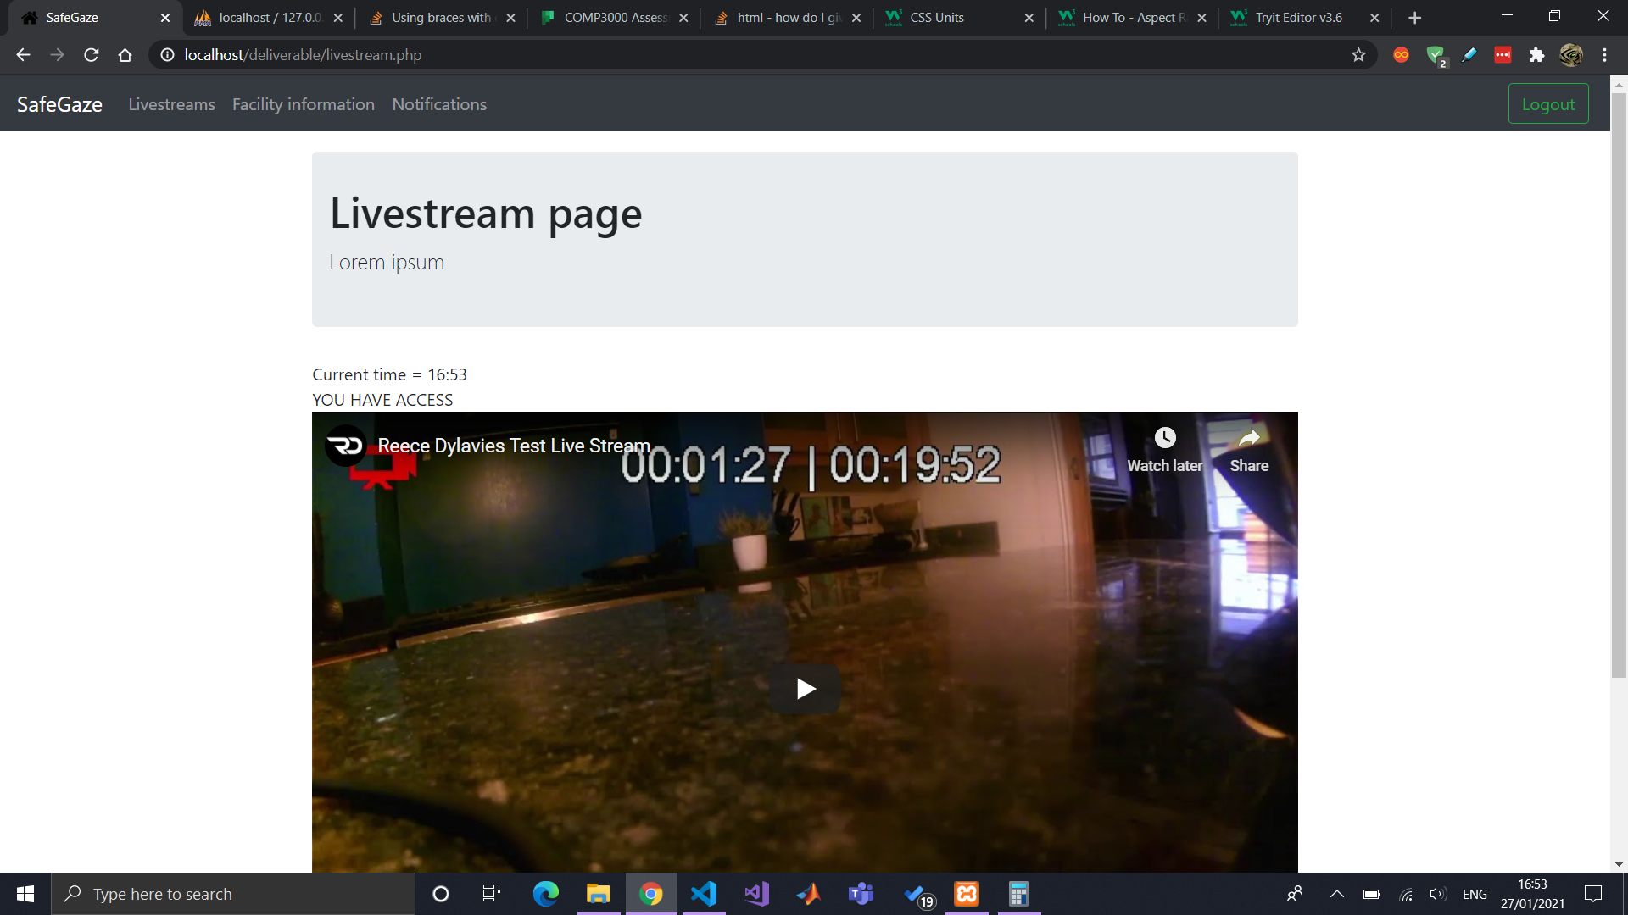

With listing all available livestreams.

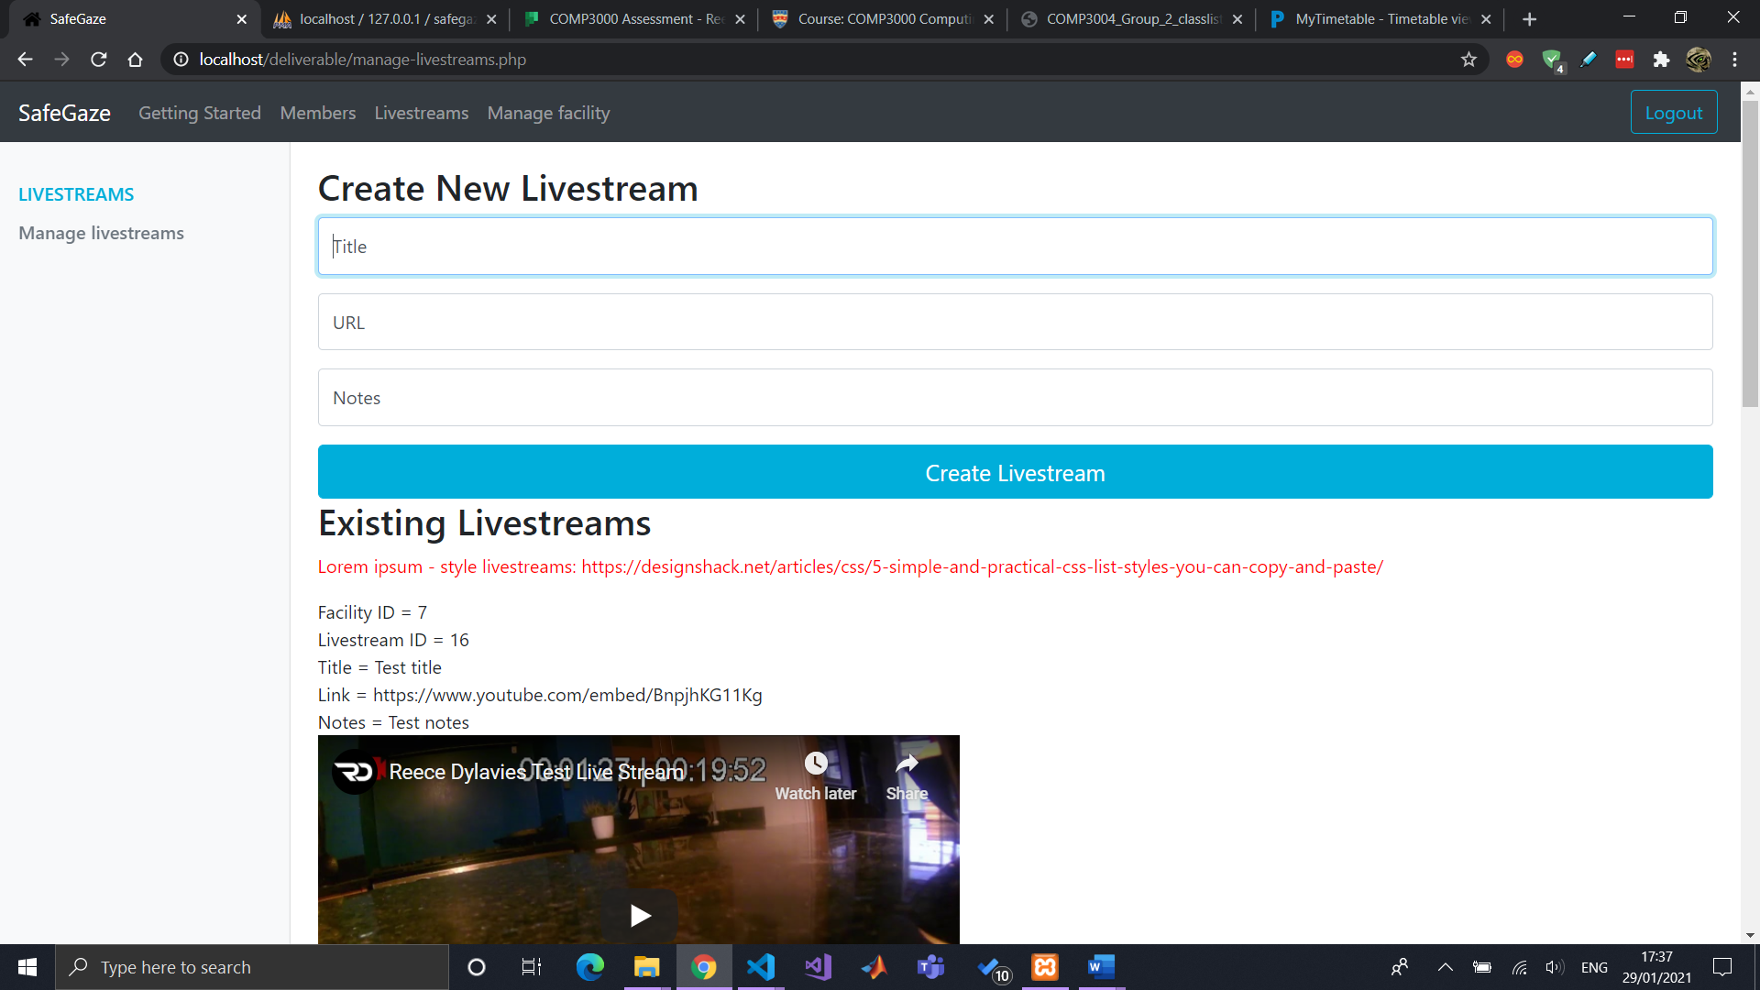

Now with styled list

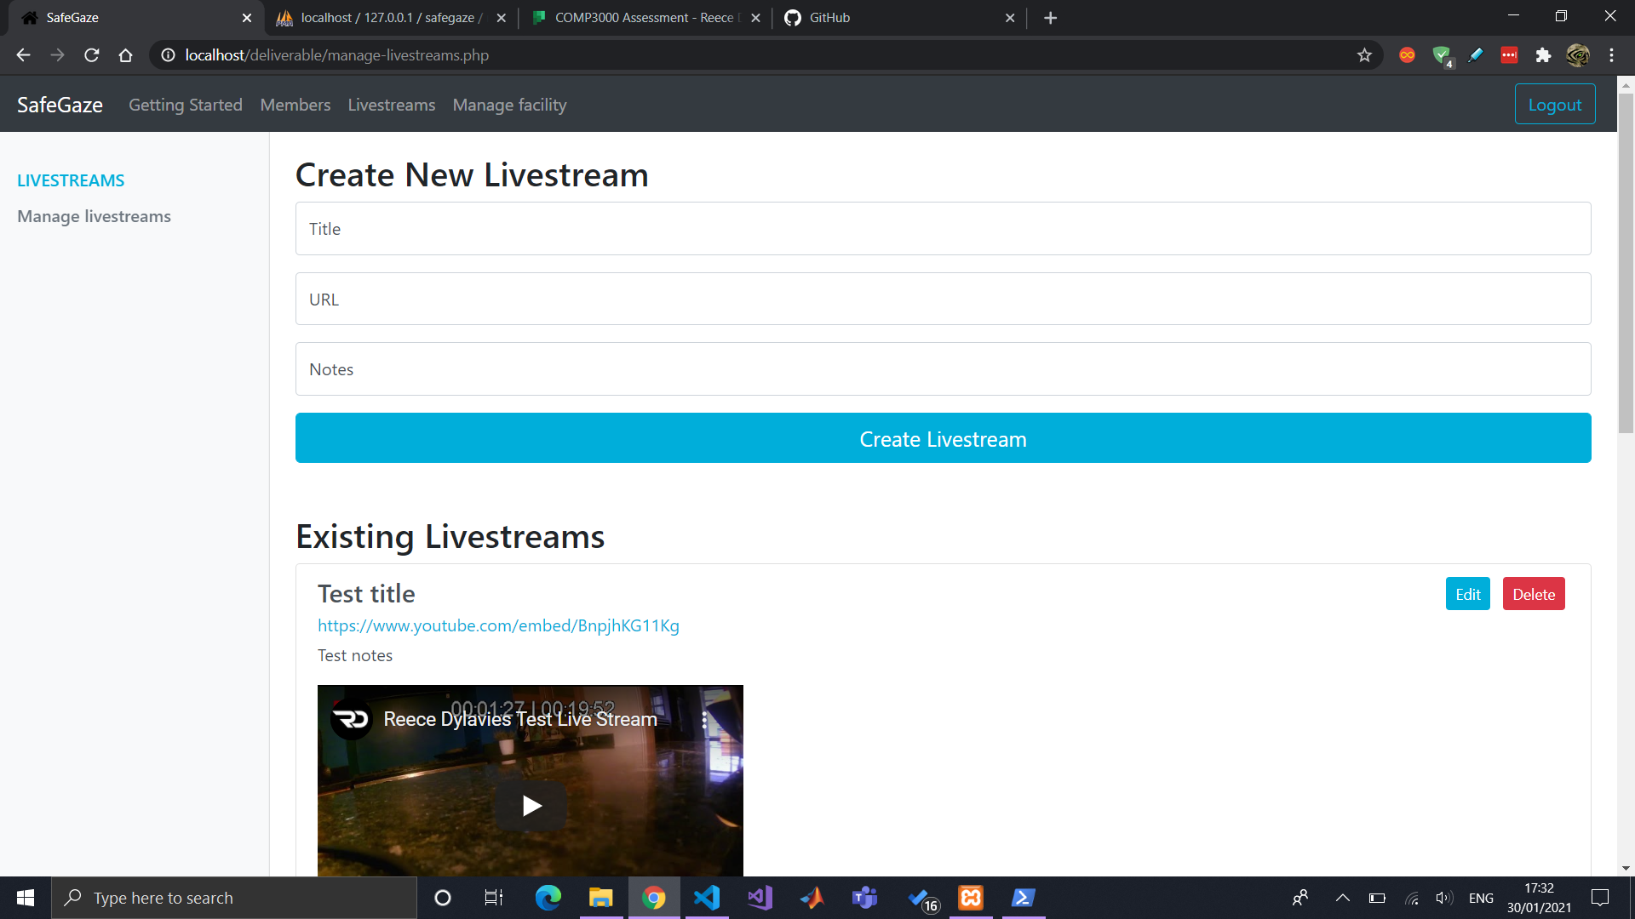

## Member to view livestream

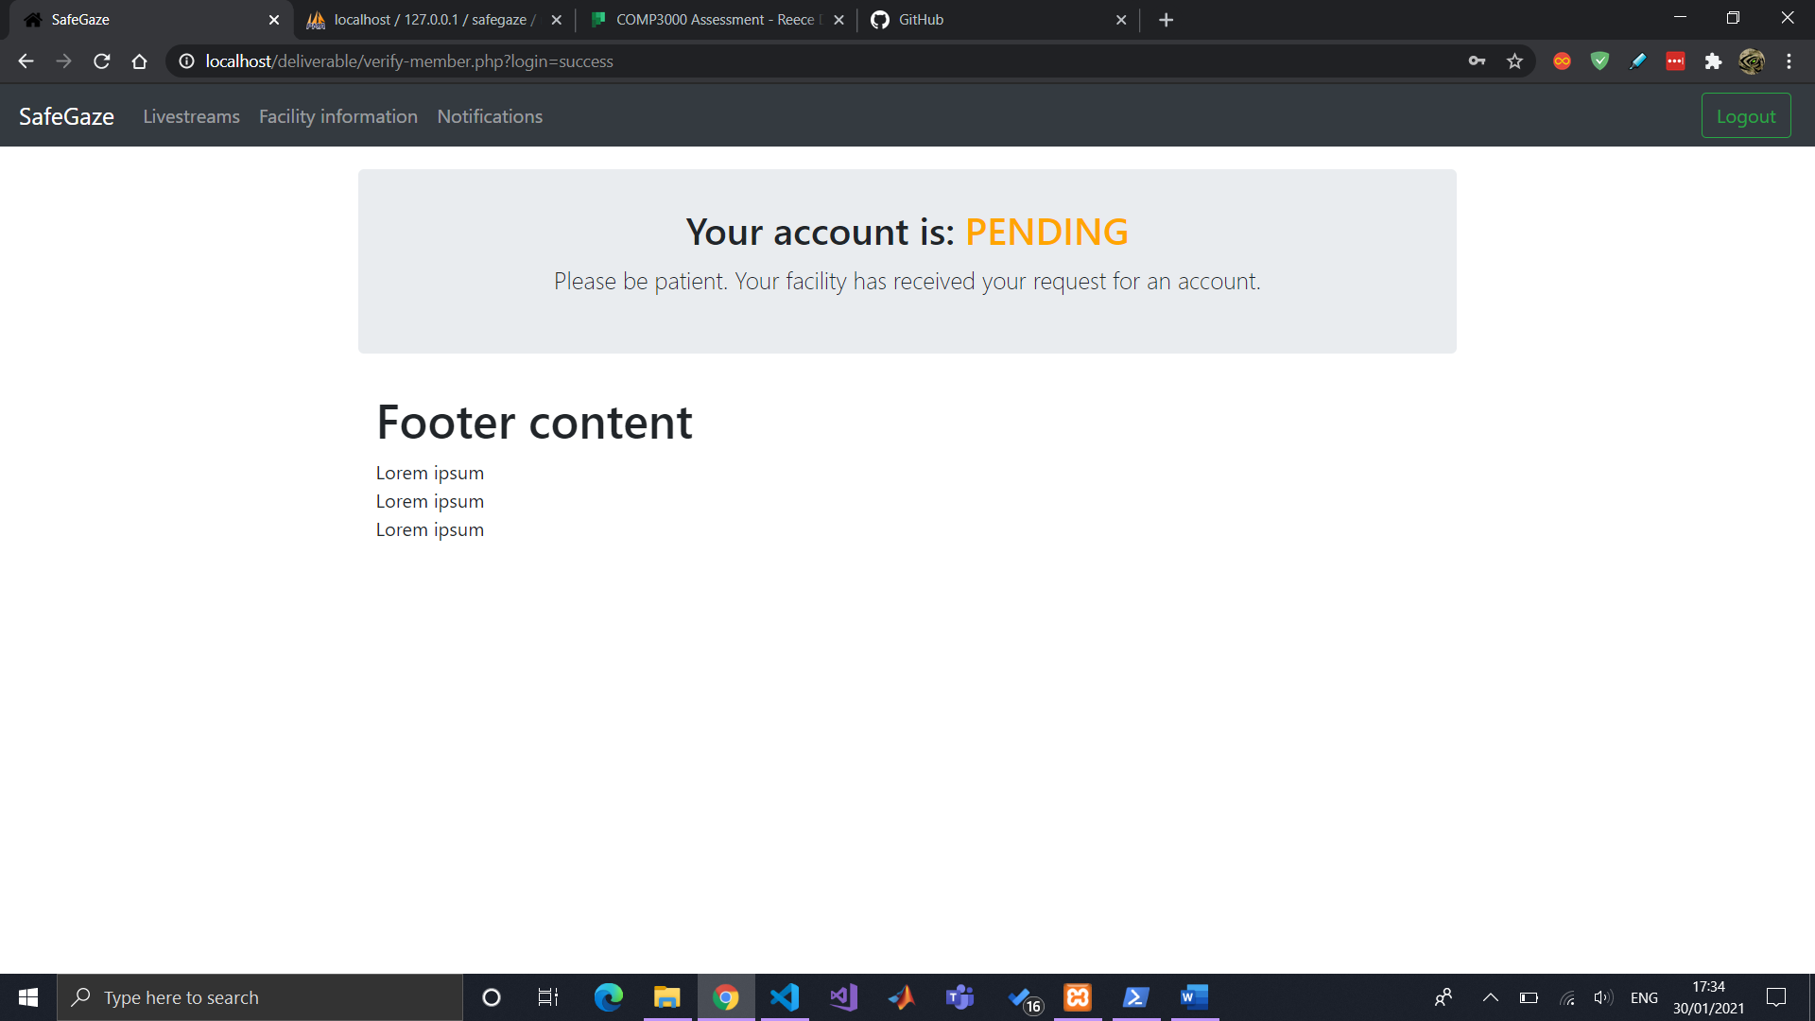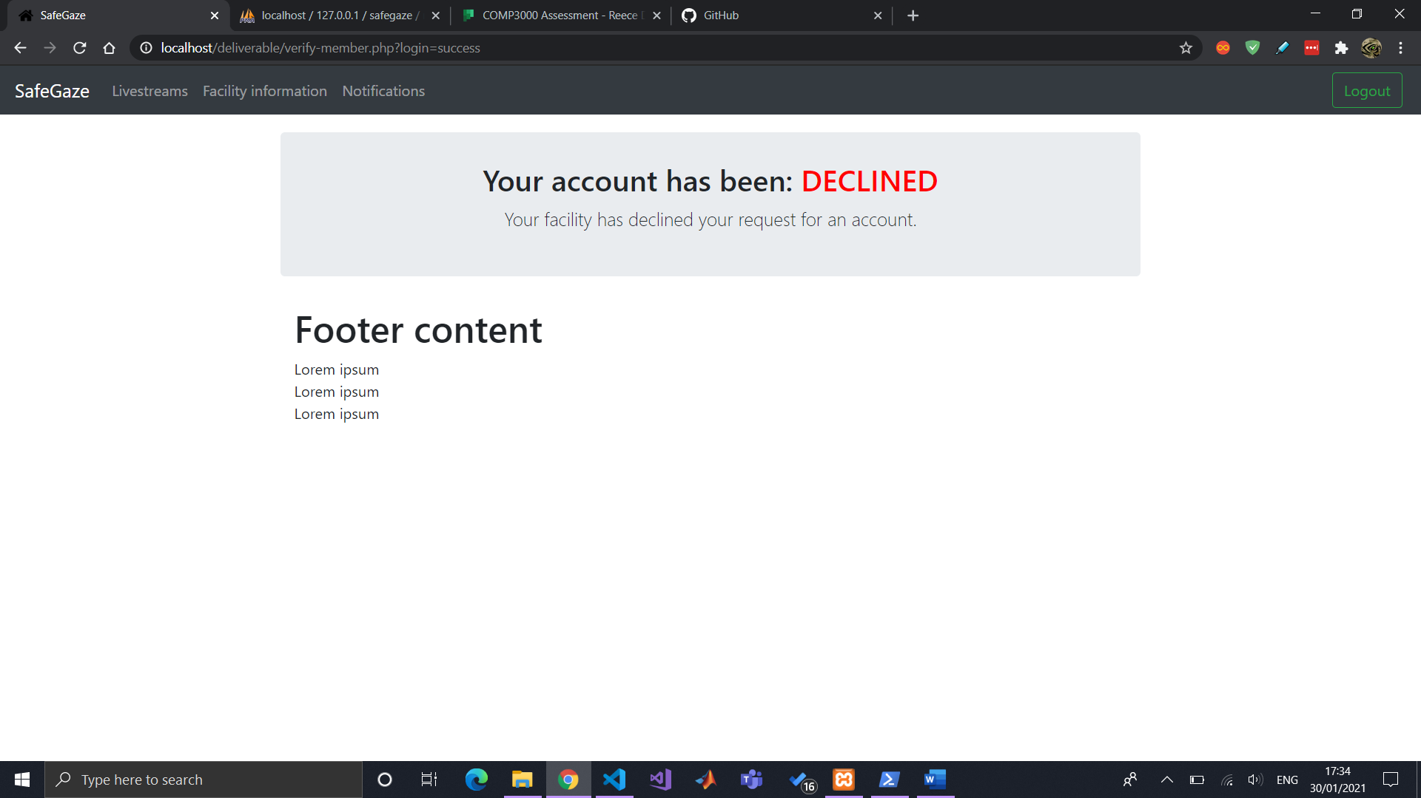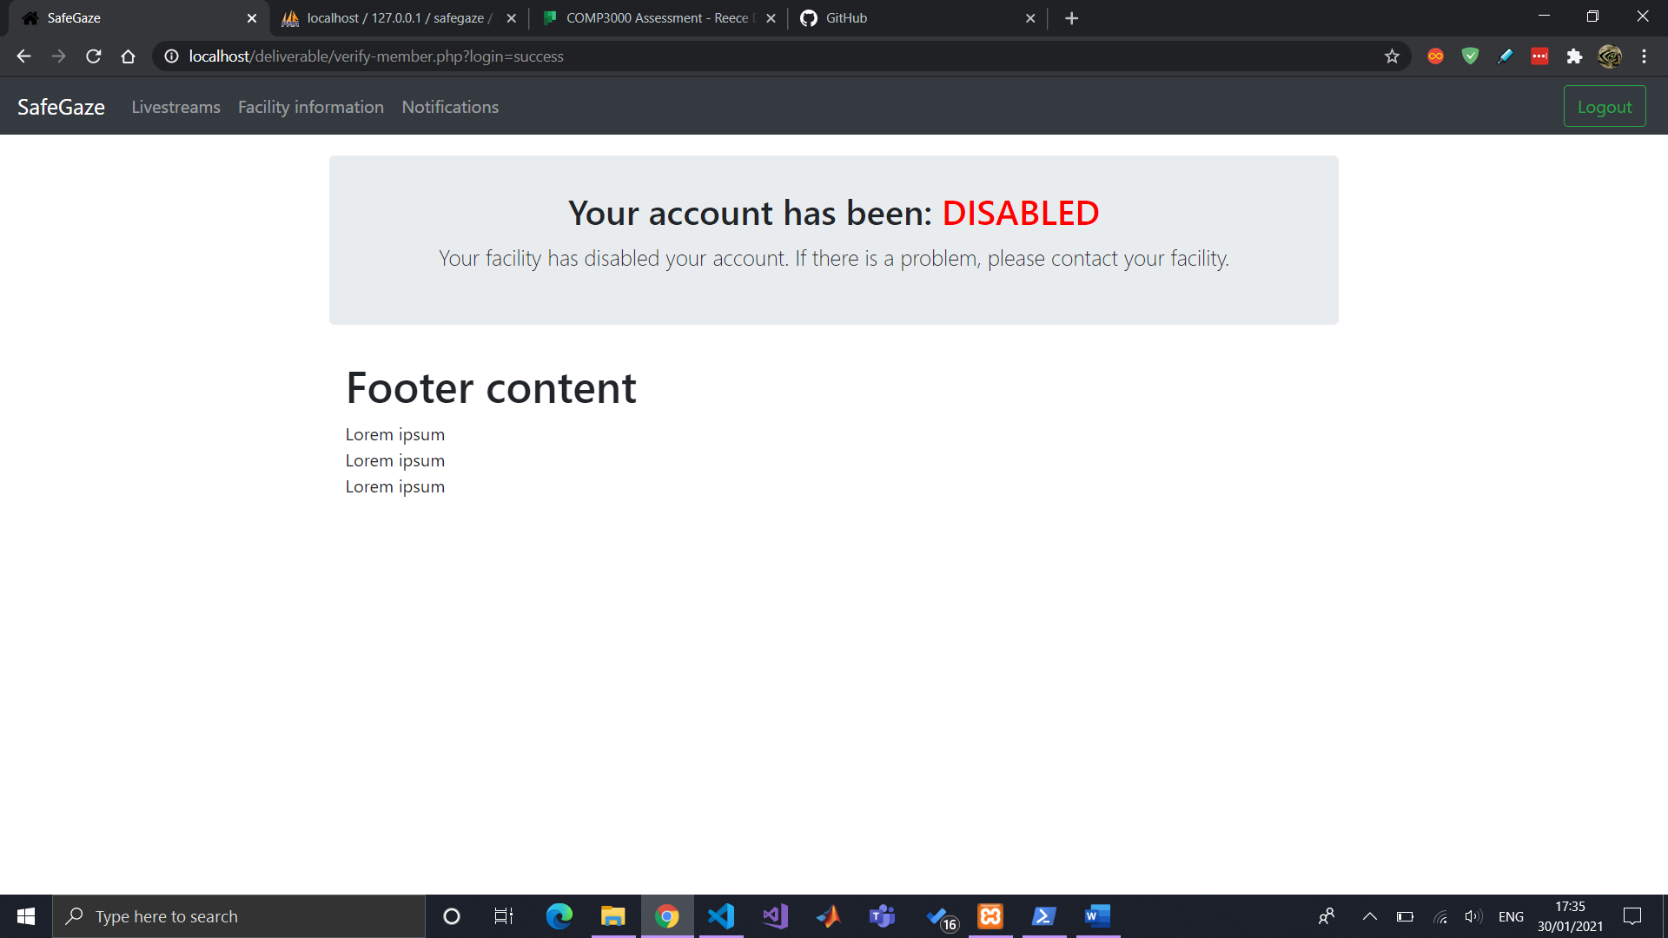

Listing a member’s access time for them to have a better understanding

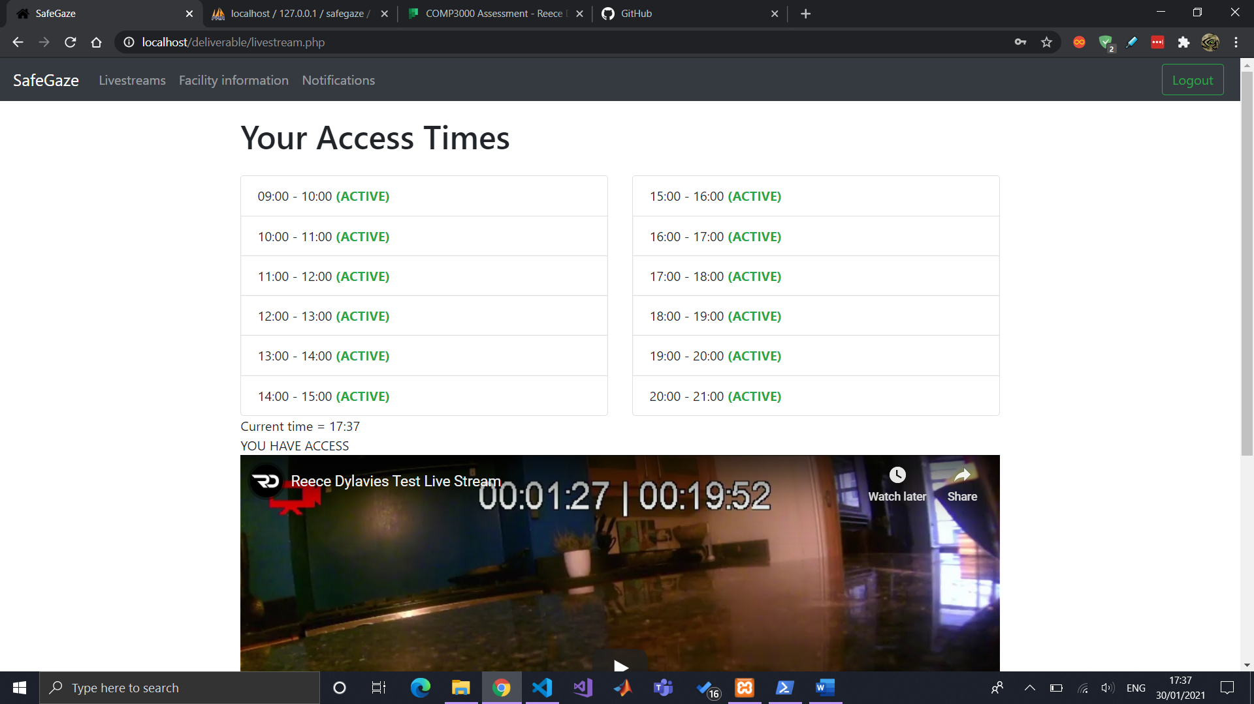

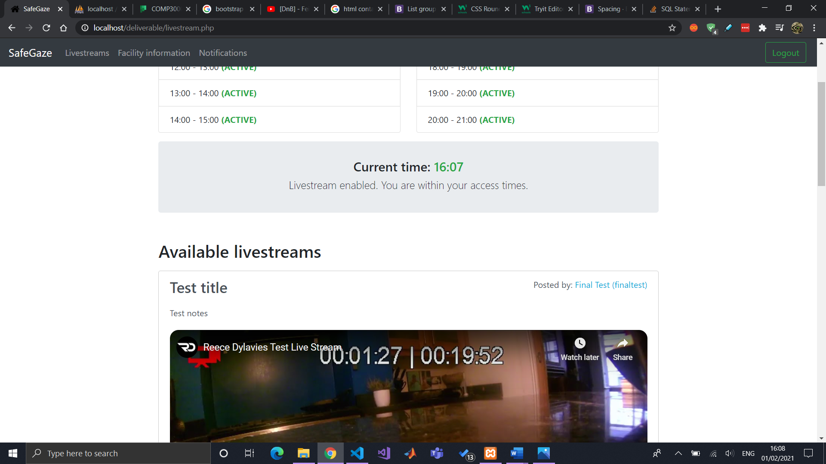

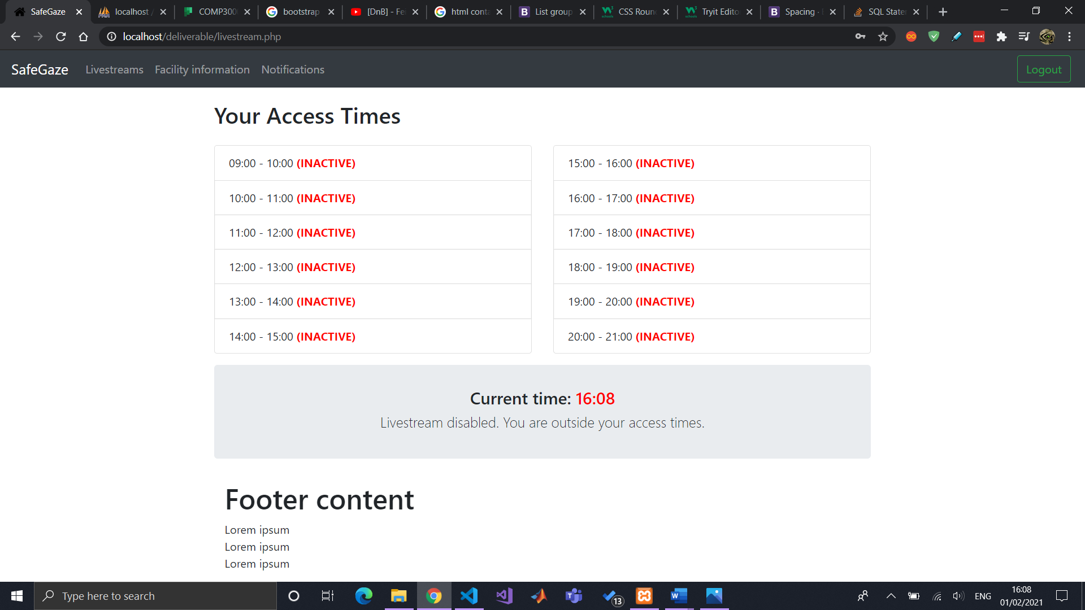

## Footer

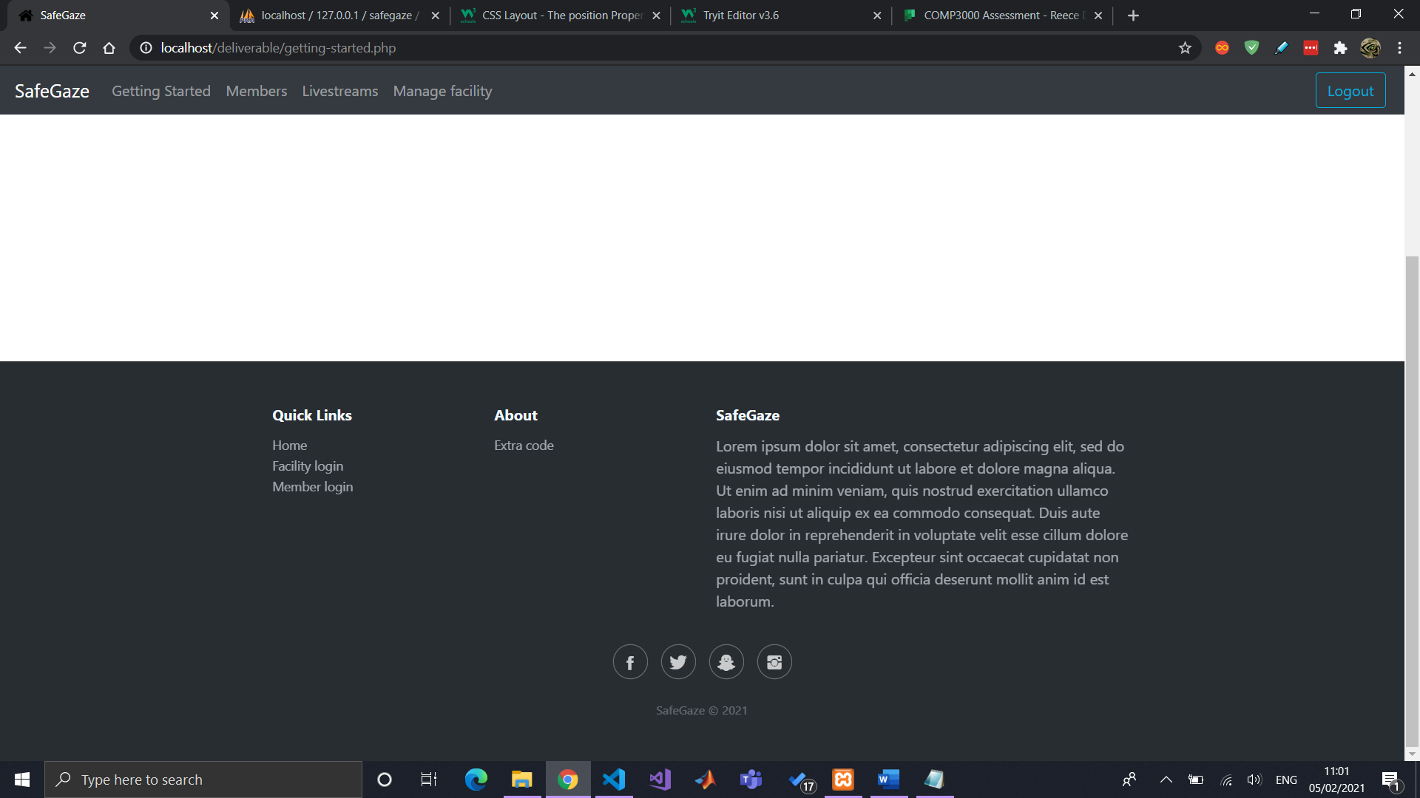

## Update facility information

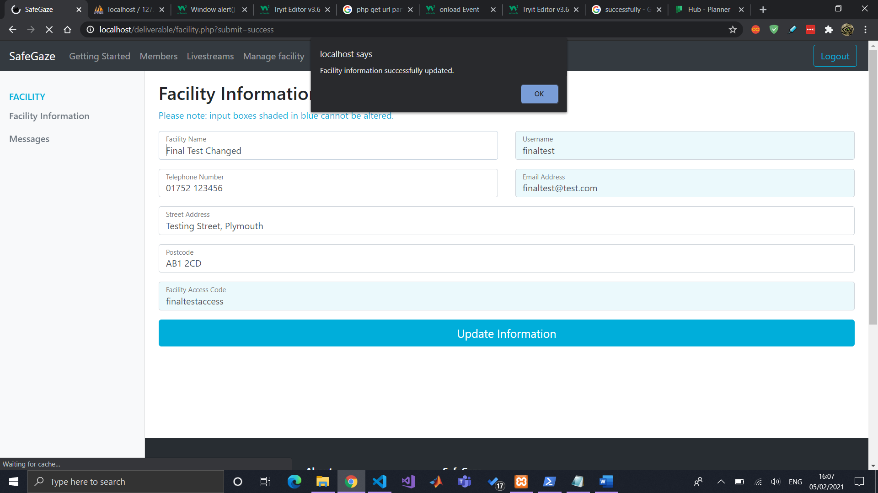

## View facility information

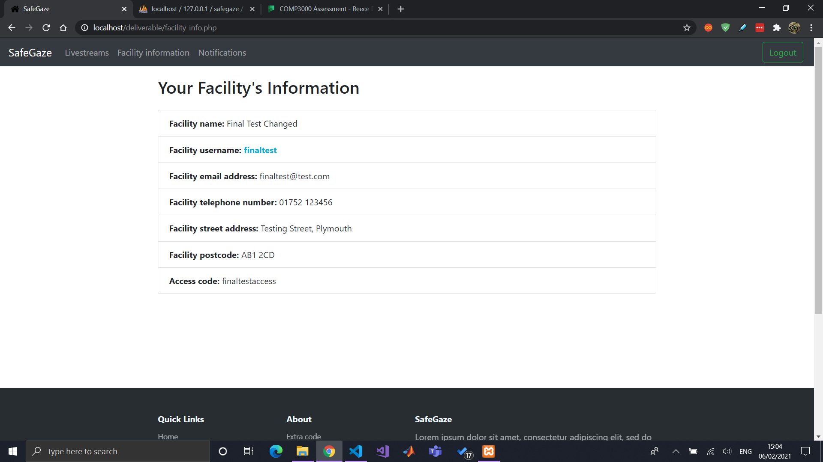

## Messages/notifications

Start of facility to create/view messages page

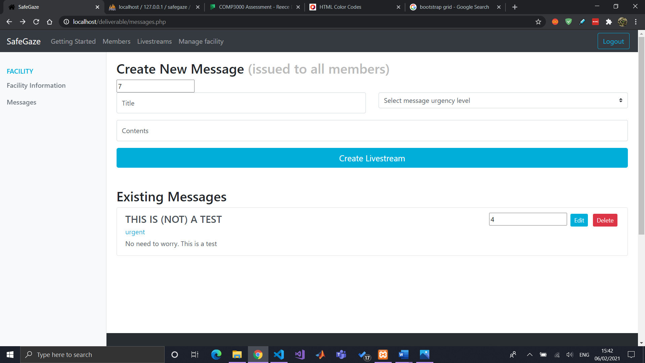

After connecting it to DB.

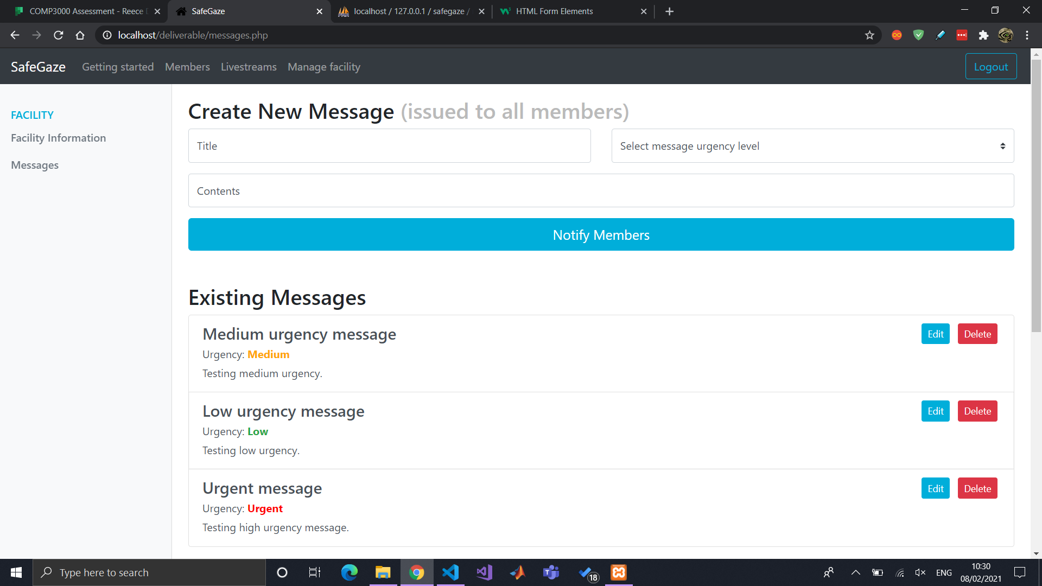

Displaying messages to members in the form of notifications

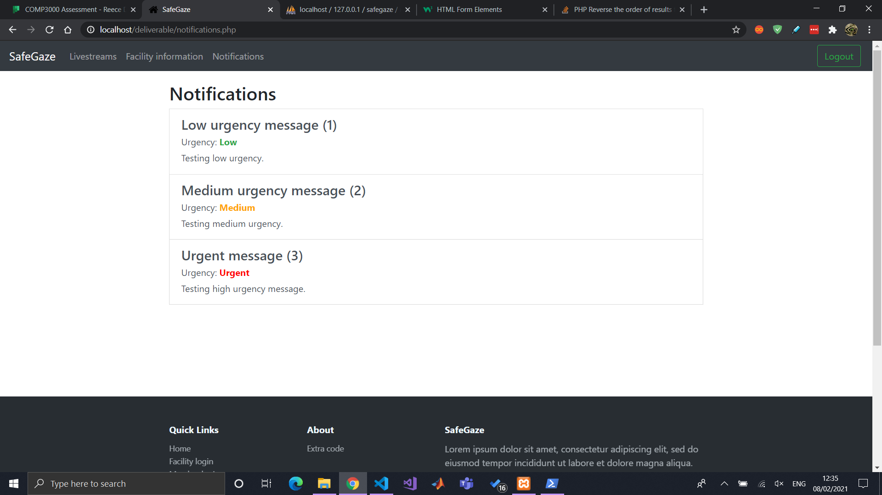

Now showing newest first with “ORDER BY message_id” DESC added to sql query (screenshot only for facility but also implemented for members).

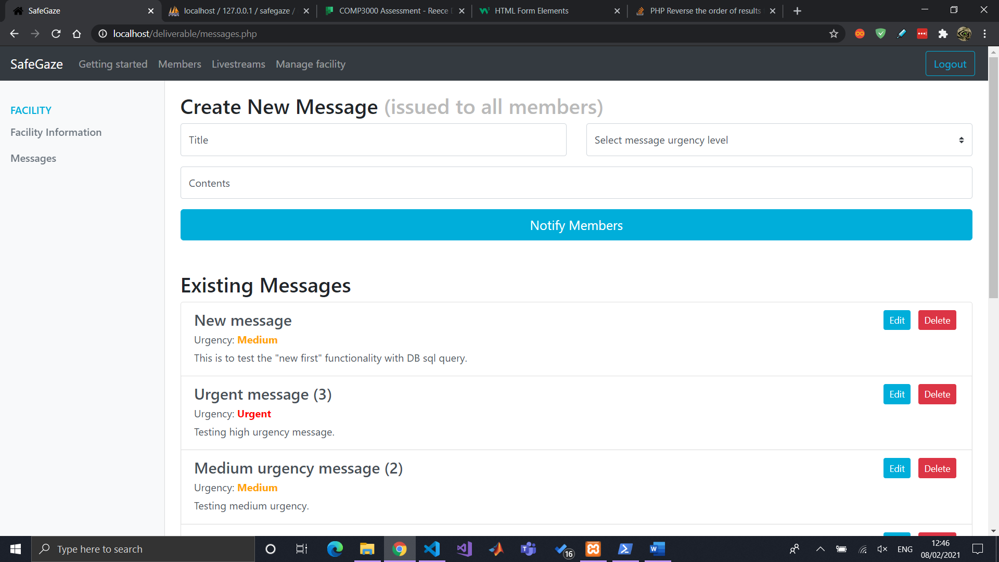

## Further (smaller changes) after functionality was (pretty much) done

Styled facility and member login as well navbar according to their colour scheme.

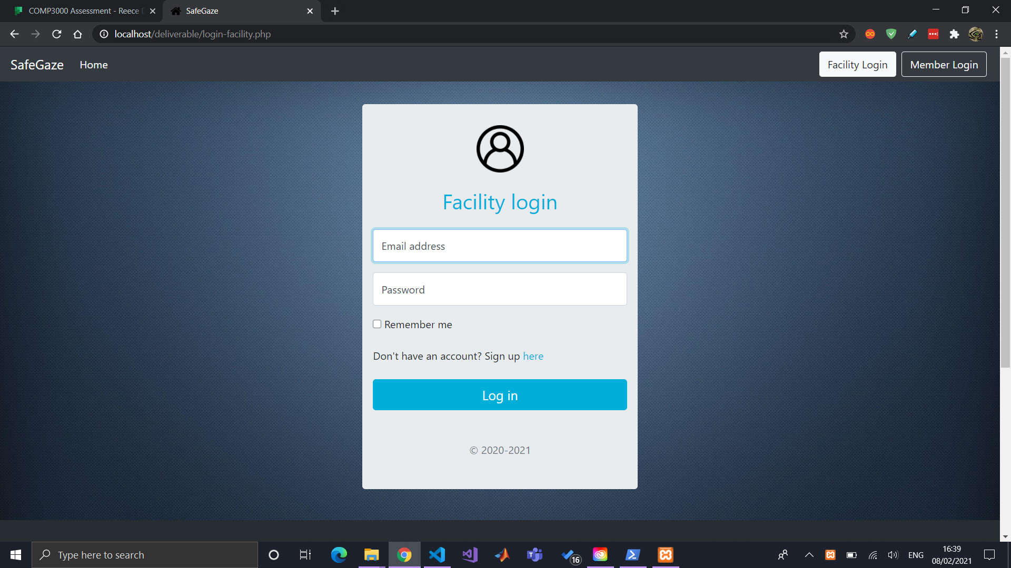



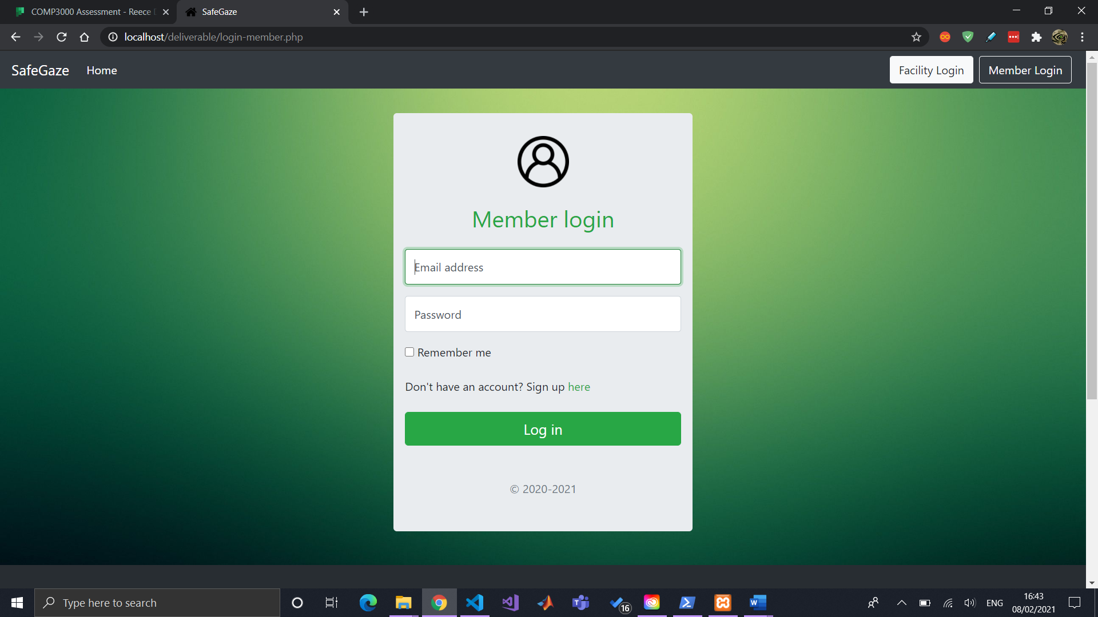

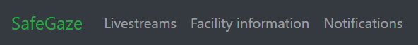

Developed a logo in Photoshop

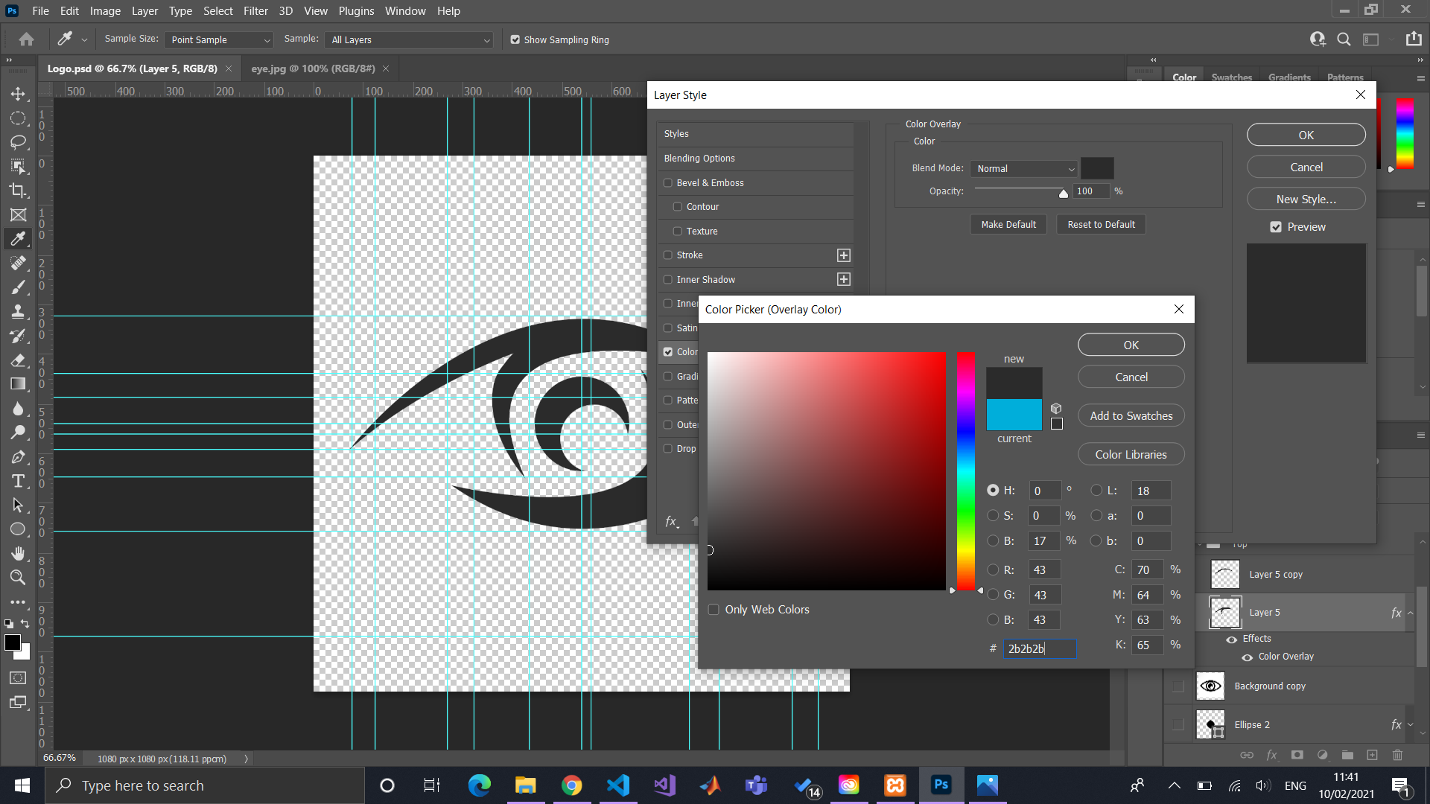

Added logo to website (header + footer)

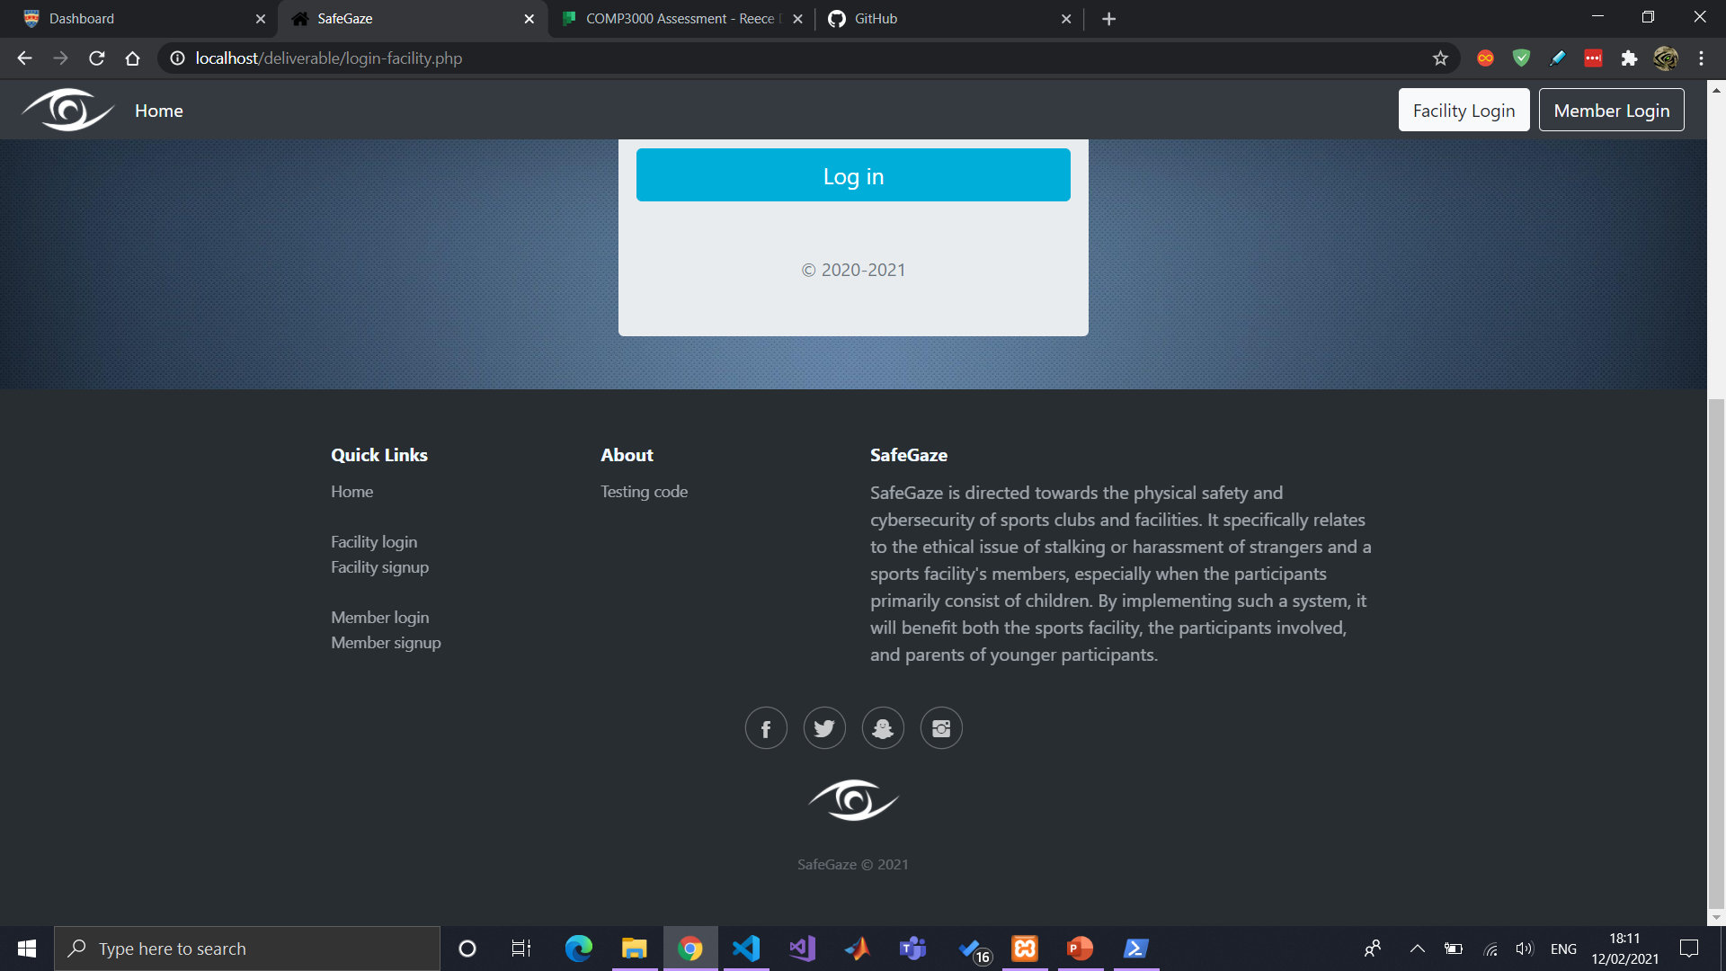

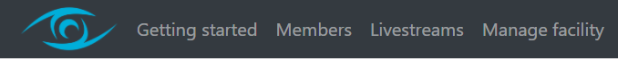

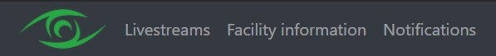

Spending so long on making the index page look decent

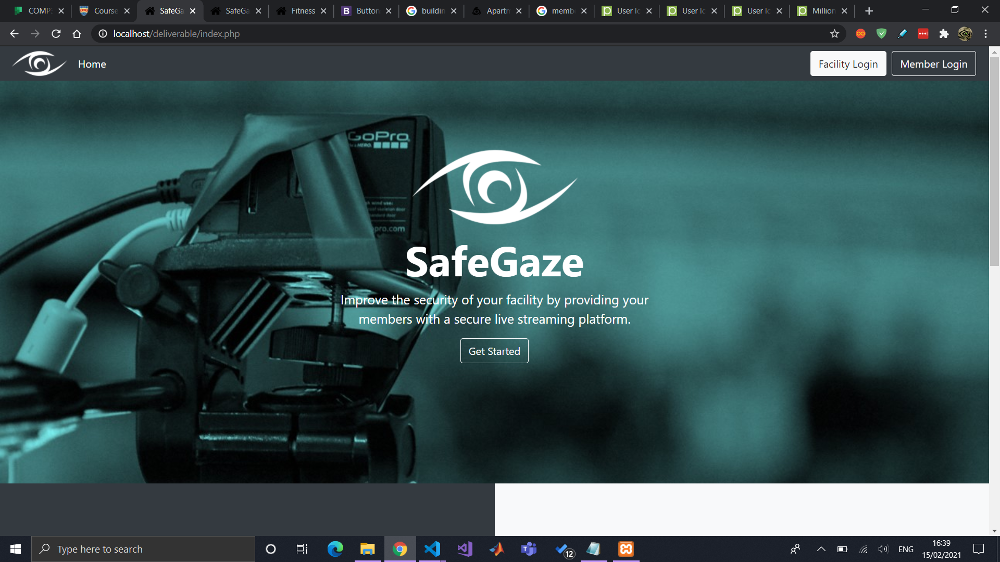

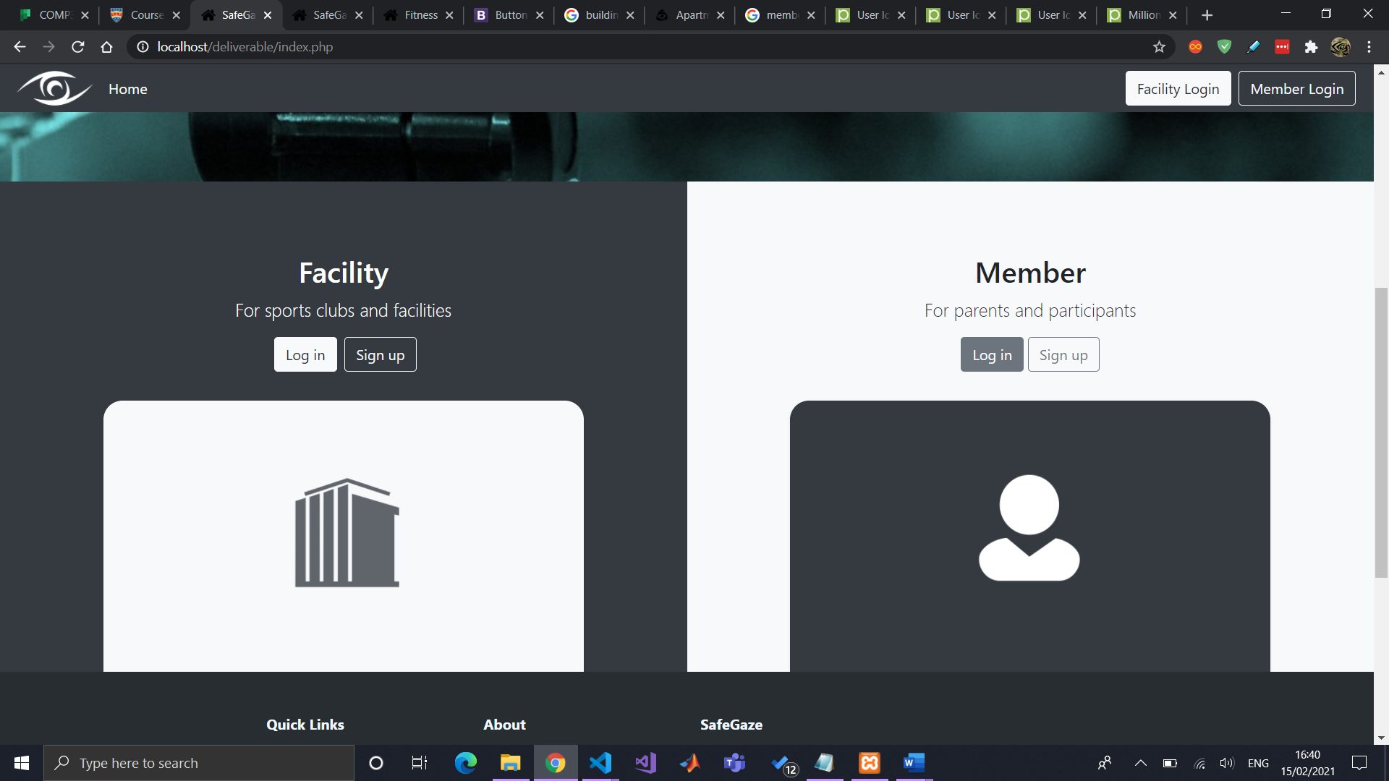

Input content into “Getting started” page, for documentation, and also acting as script for showcase video demonstration.

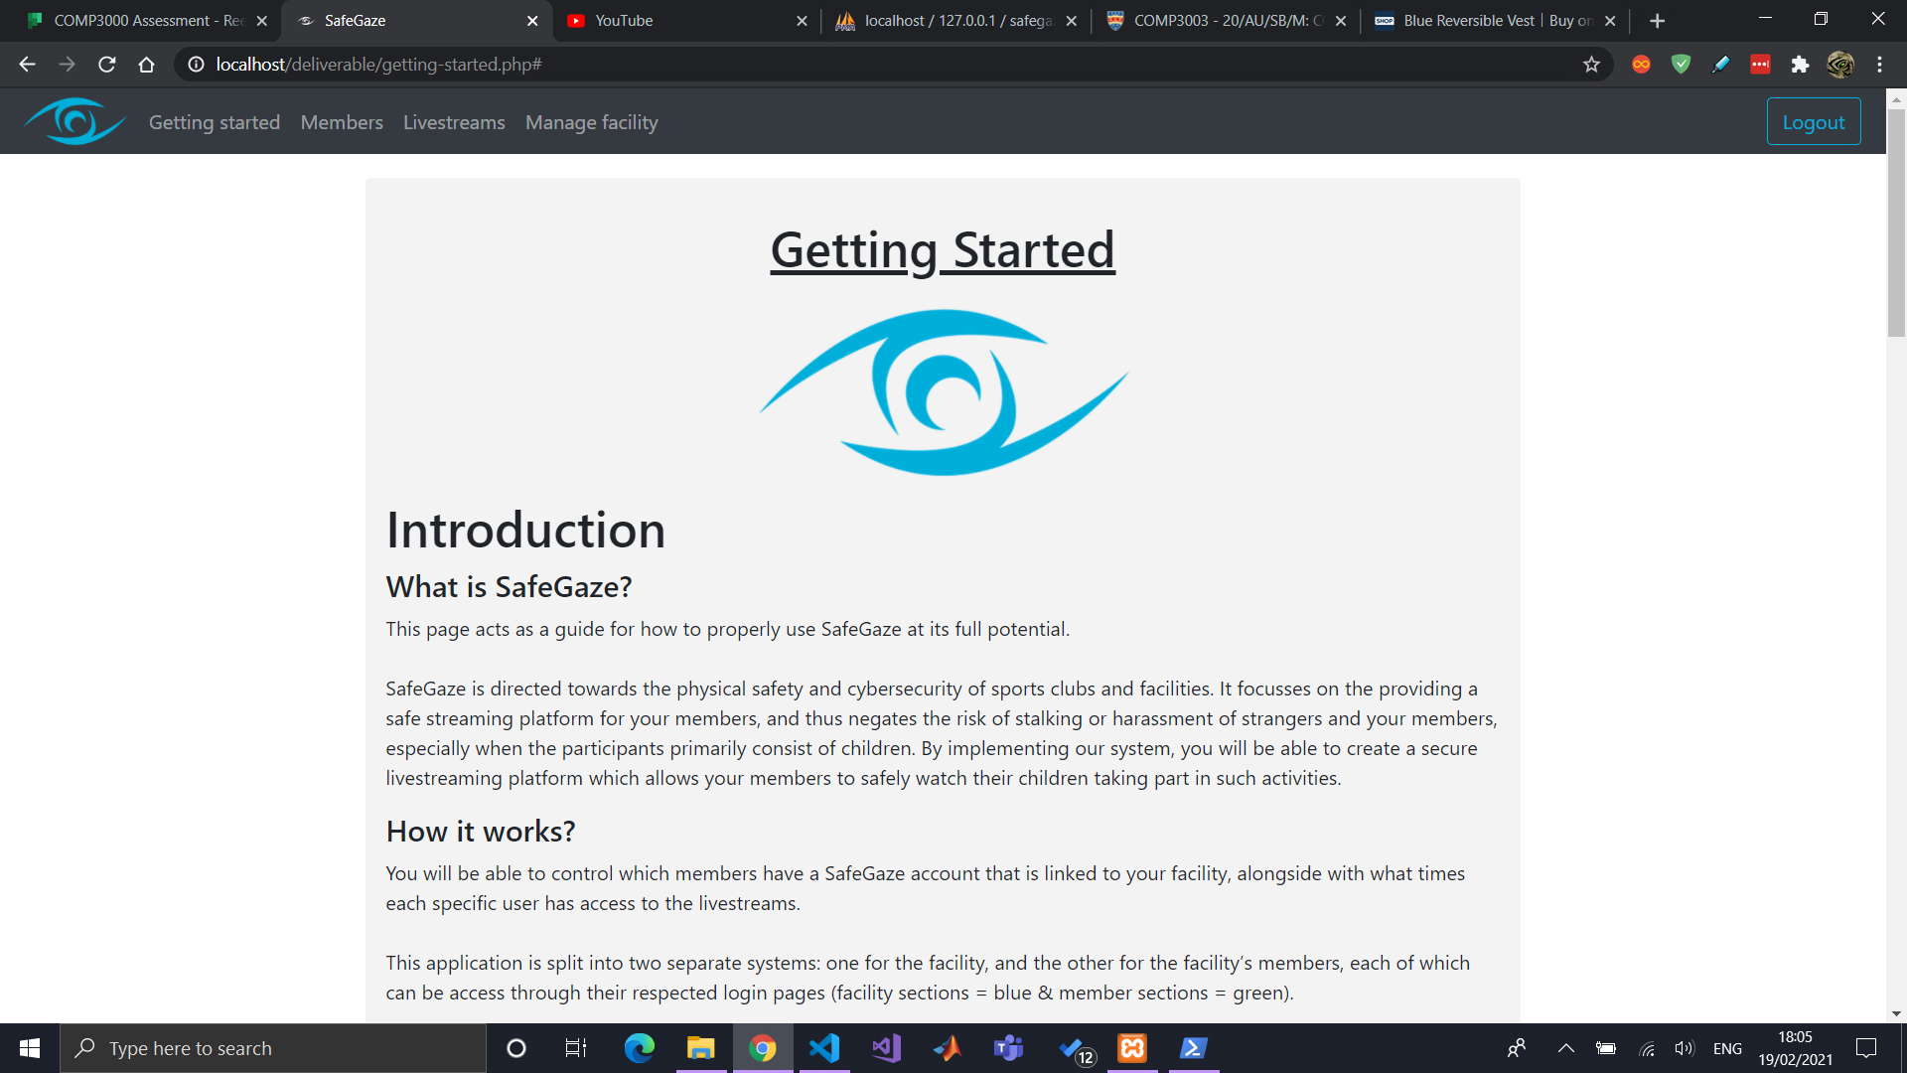

Poster start

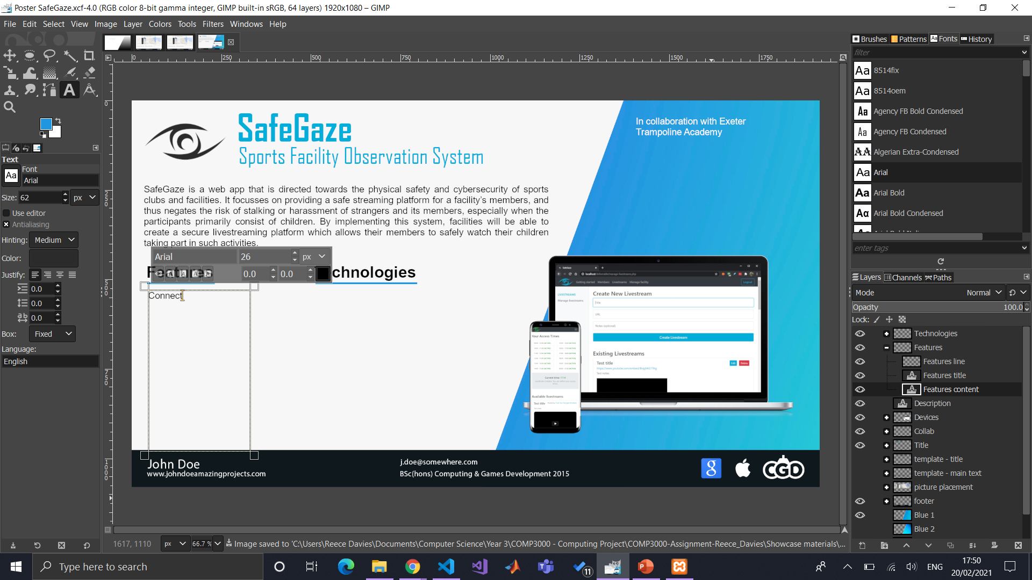

## Edit a livestream

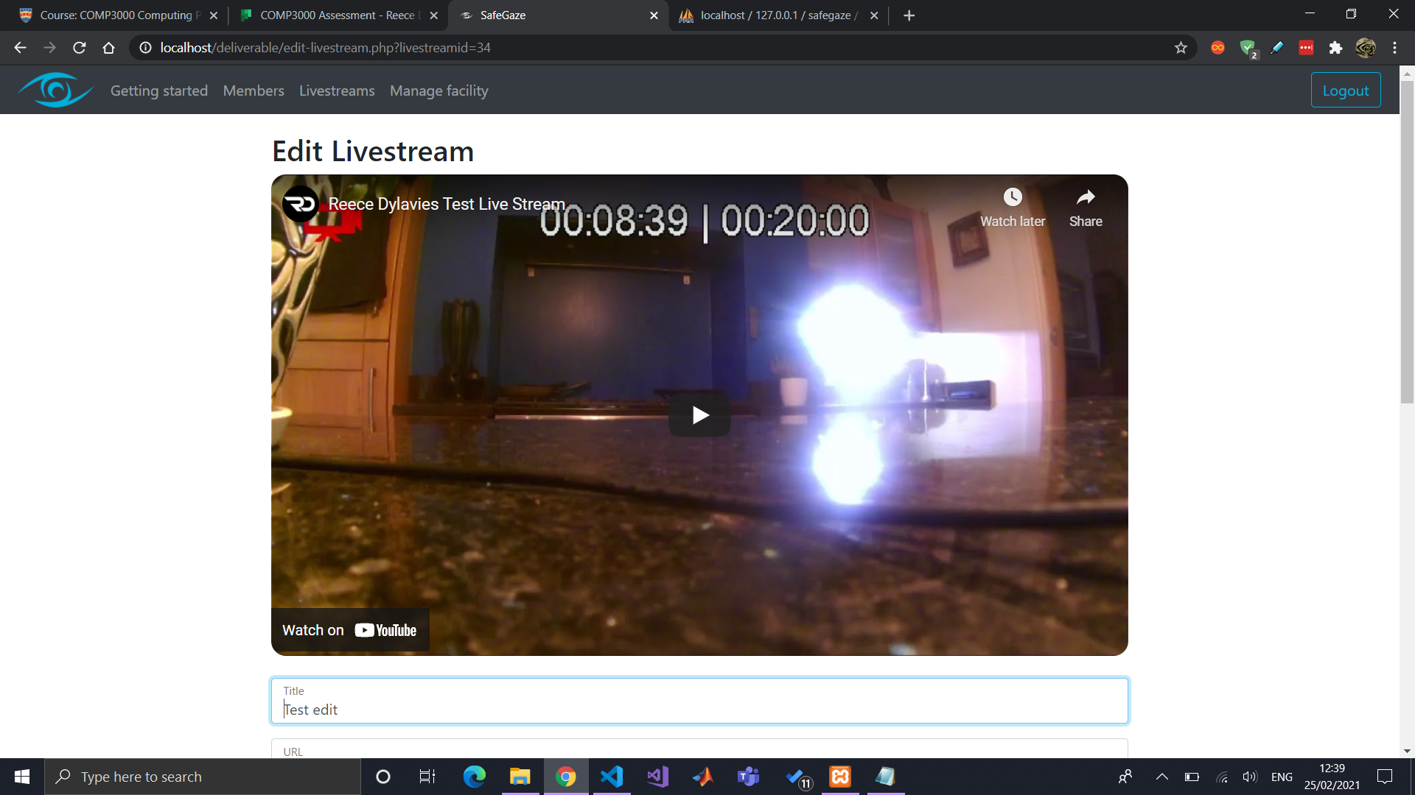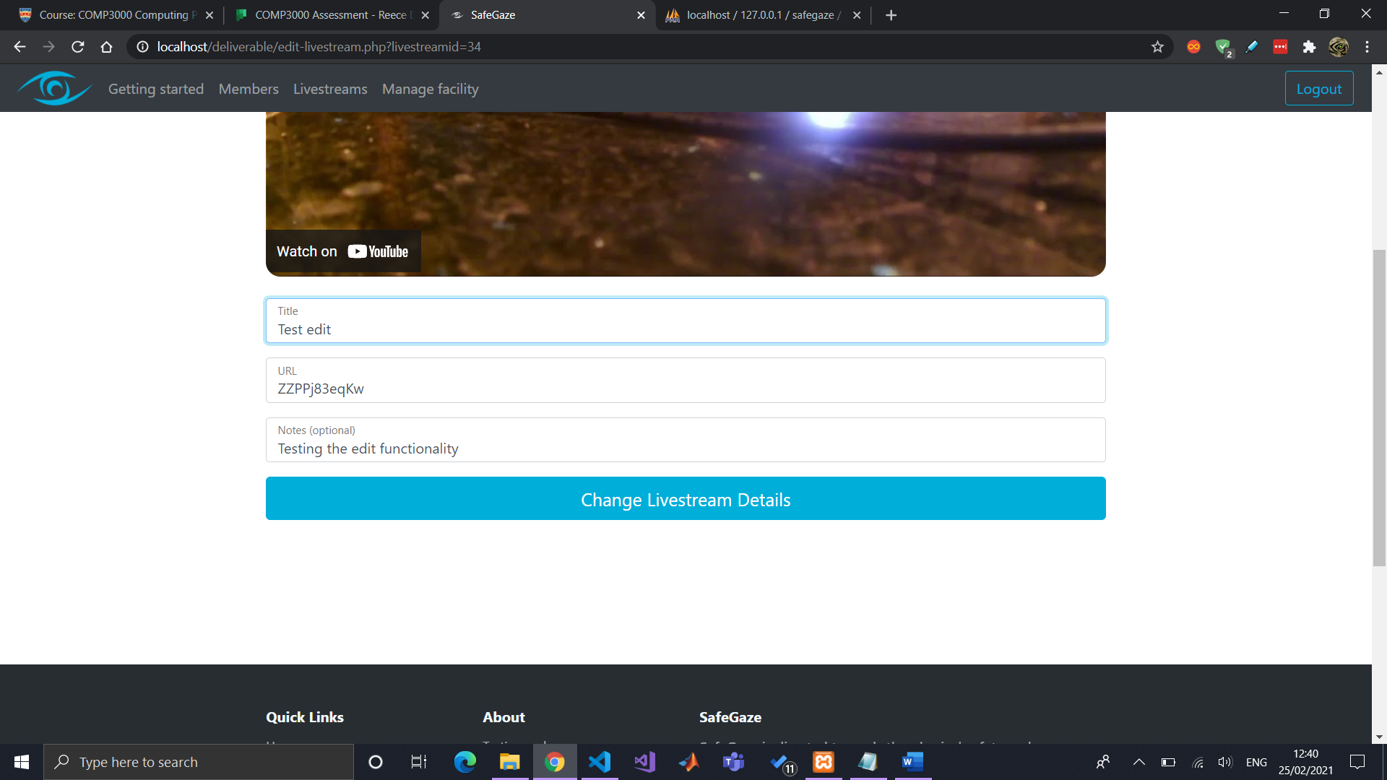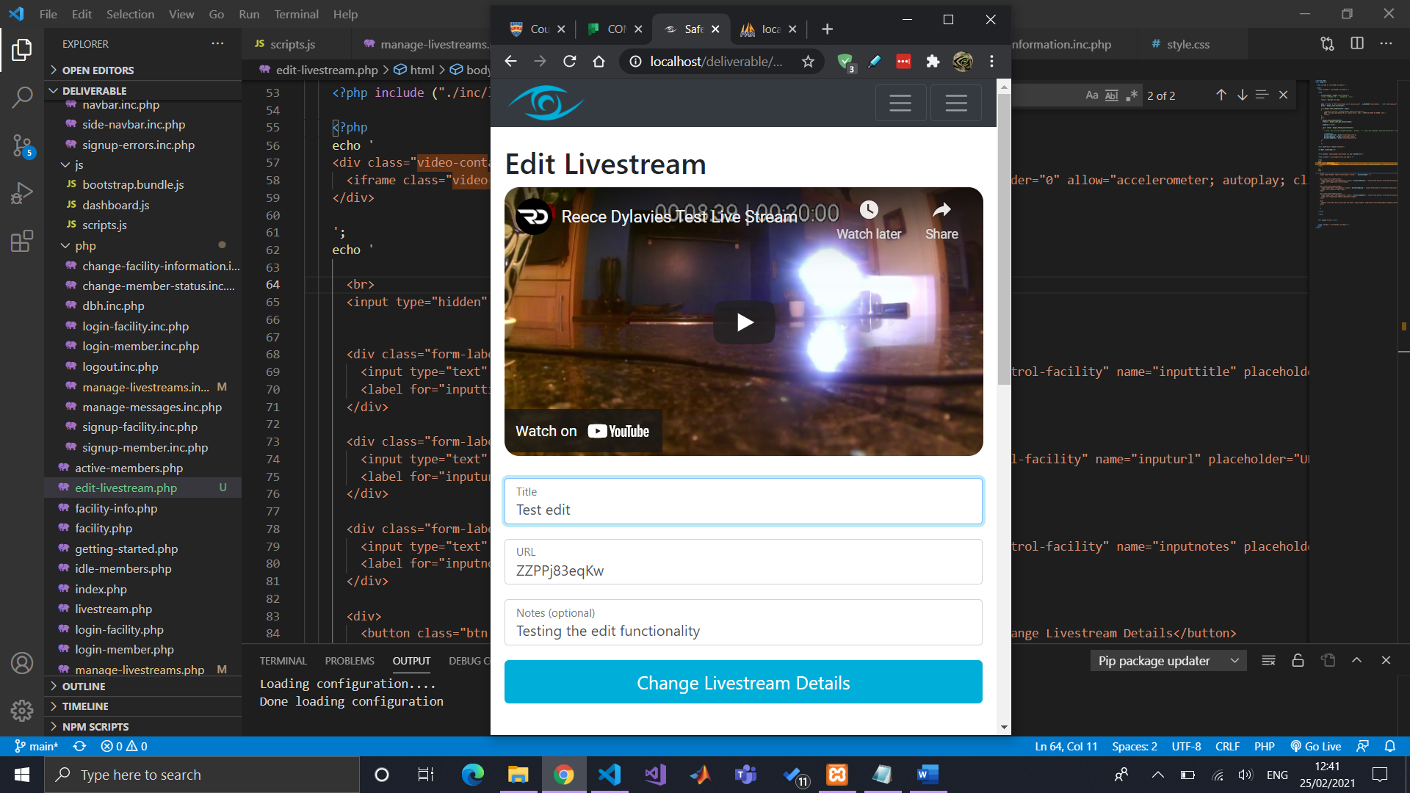

# Improvements after university: access times

## (Old) Creating new tables and relationship (how to)

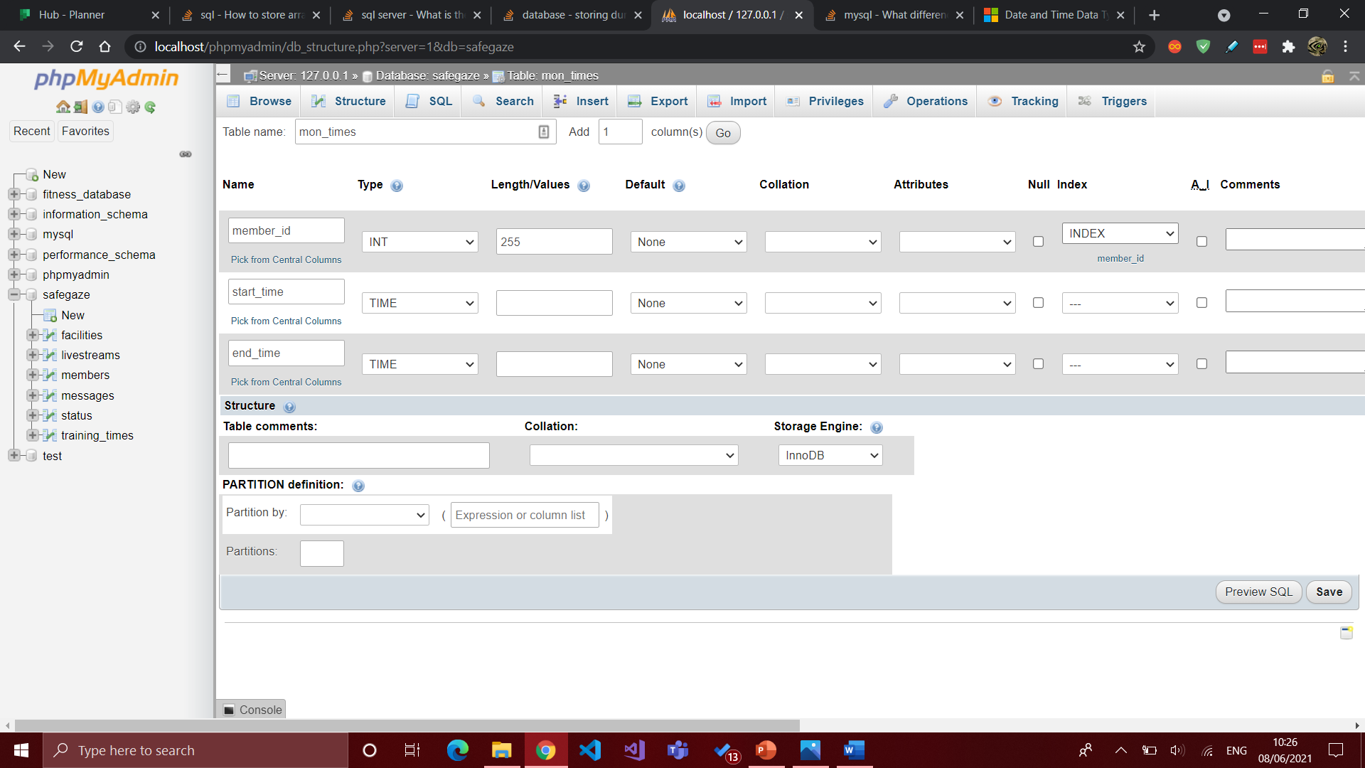

Before relationship

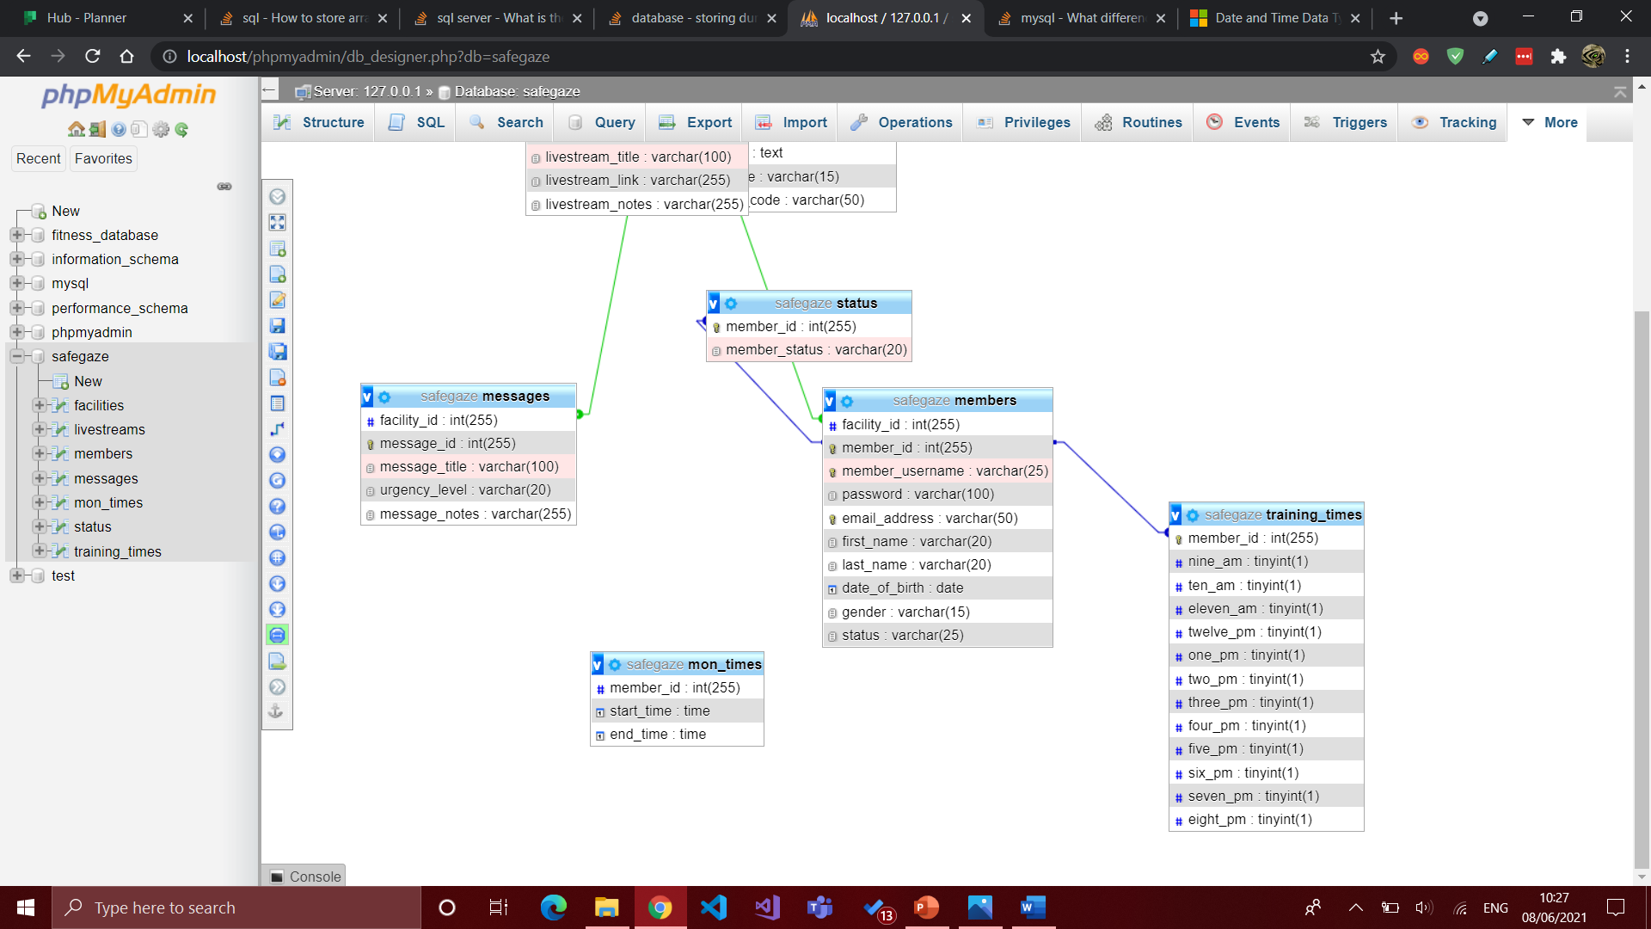

After created relationship

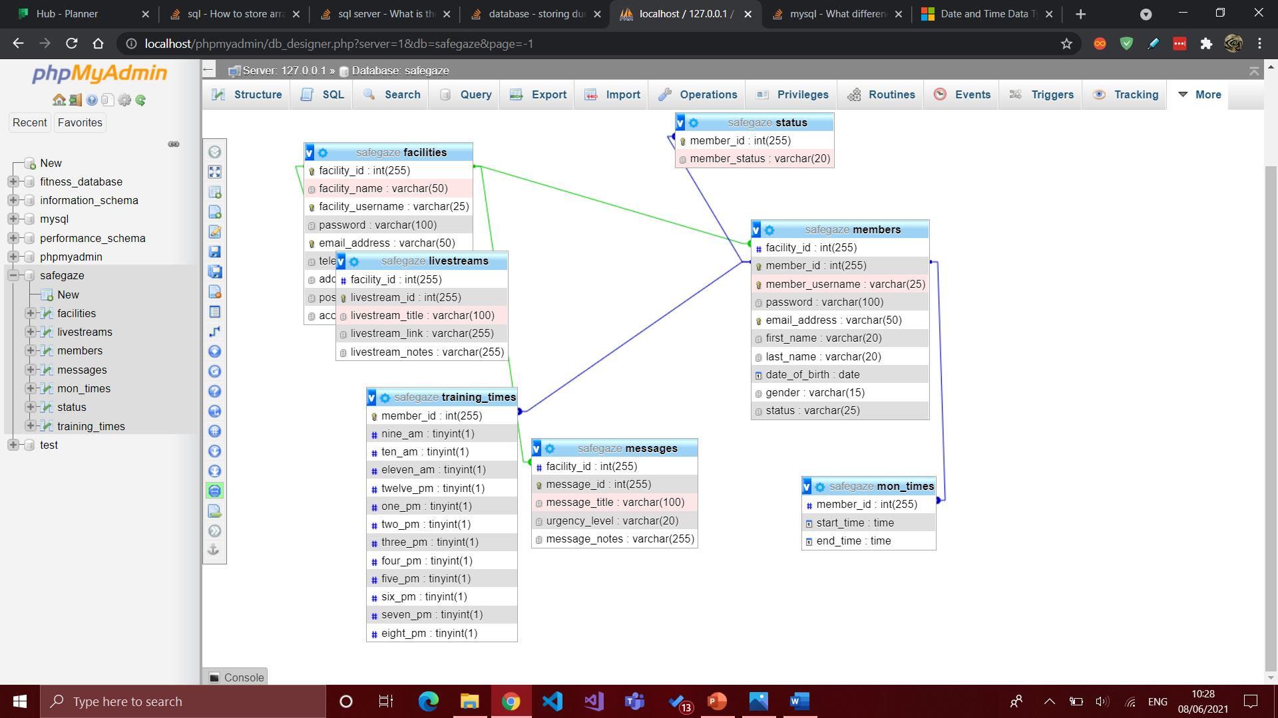

## Show table with inserted data

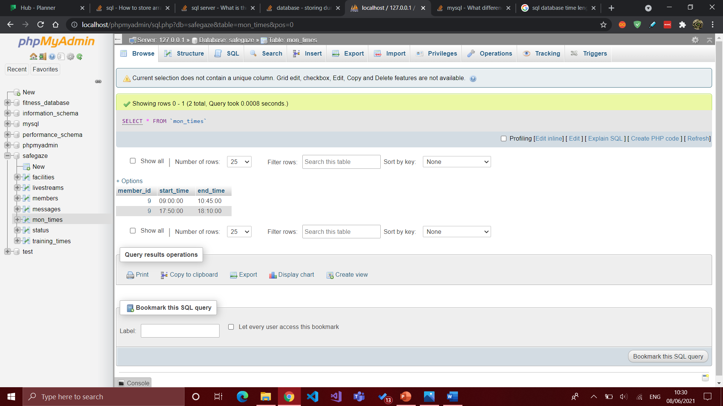

## New database ERD screenshot (still has old training times)

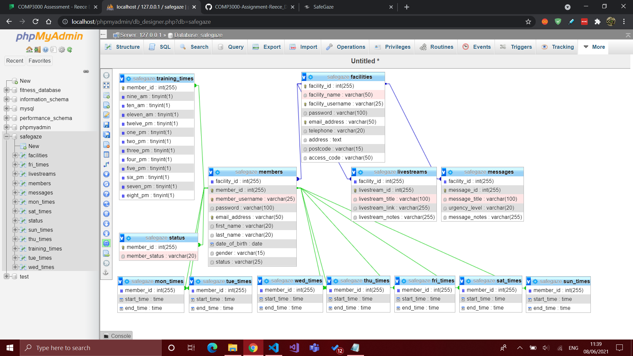

## Recreating new access times tables (how to)

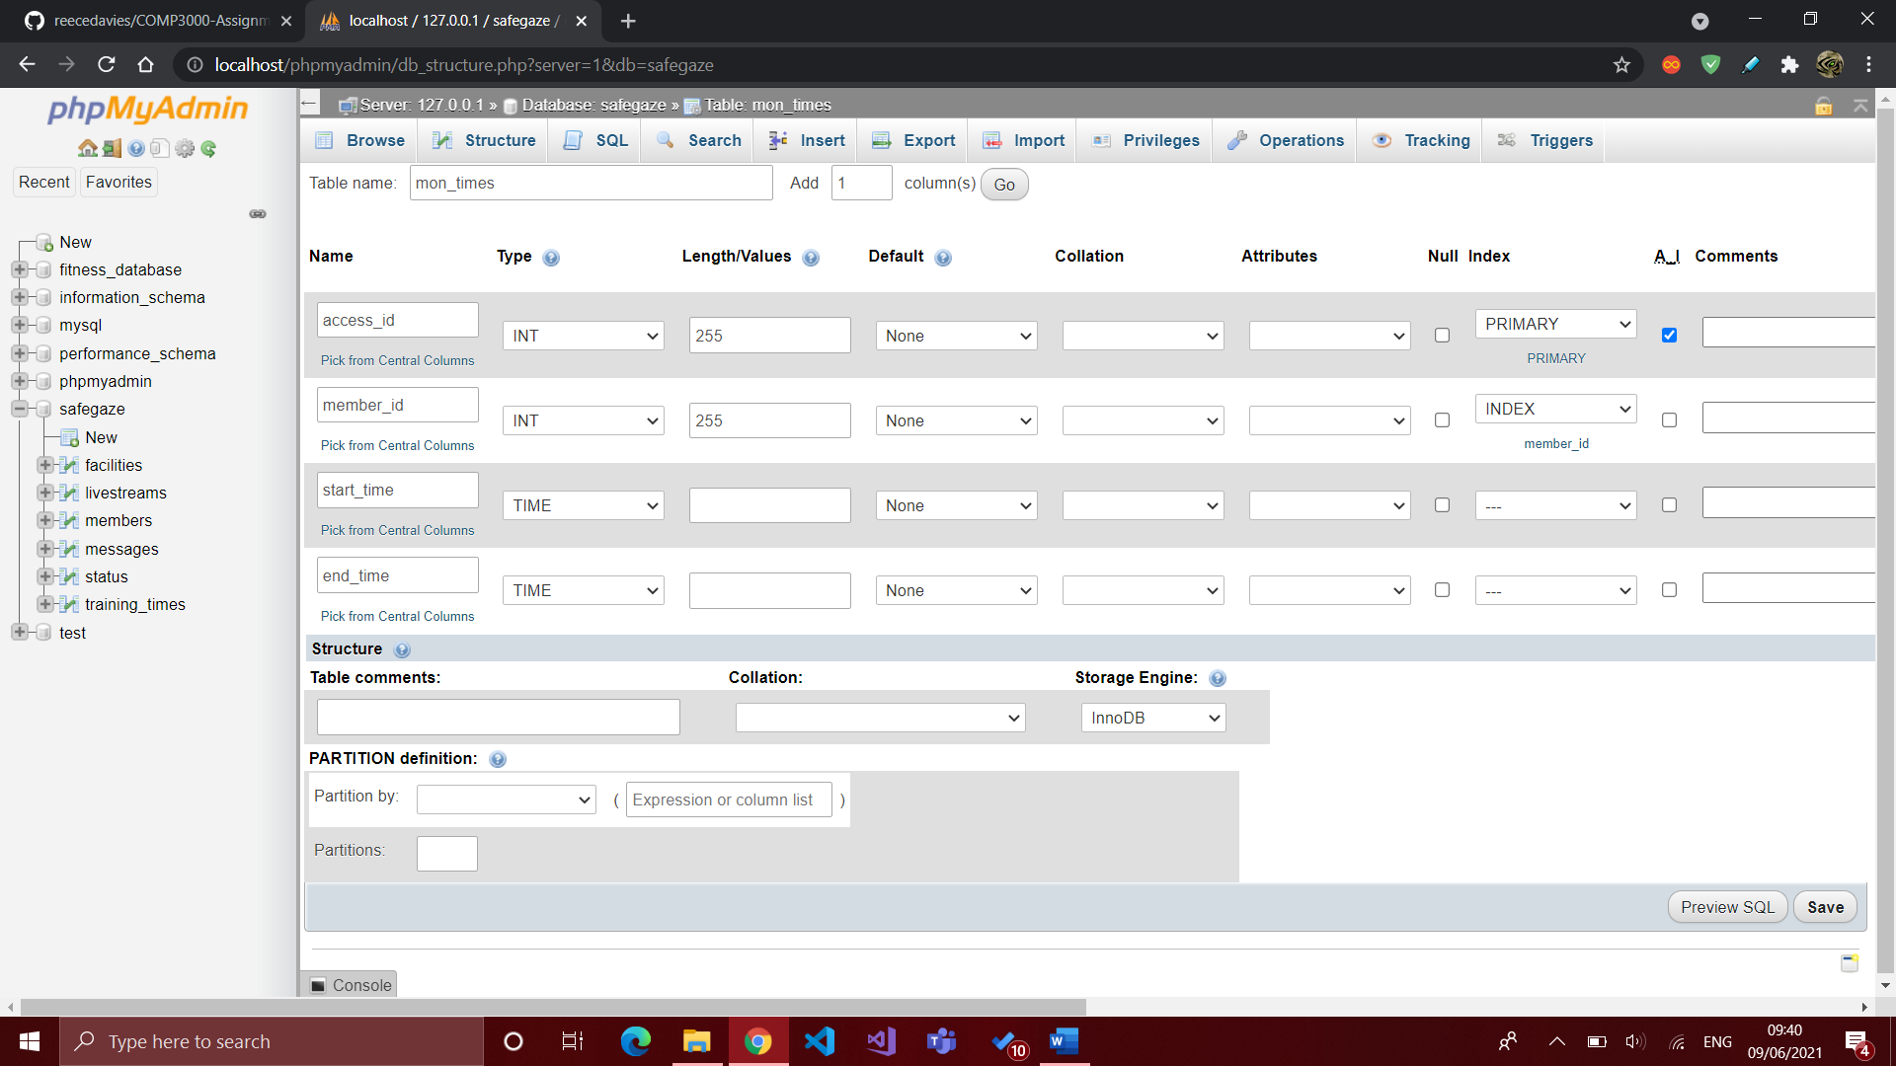

And then adding relationship

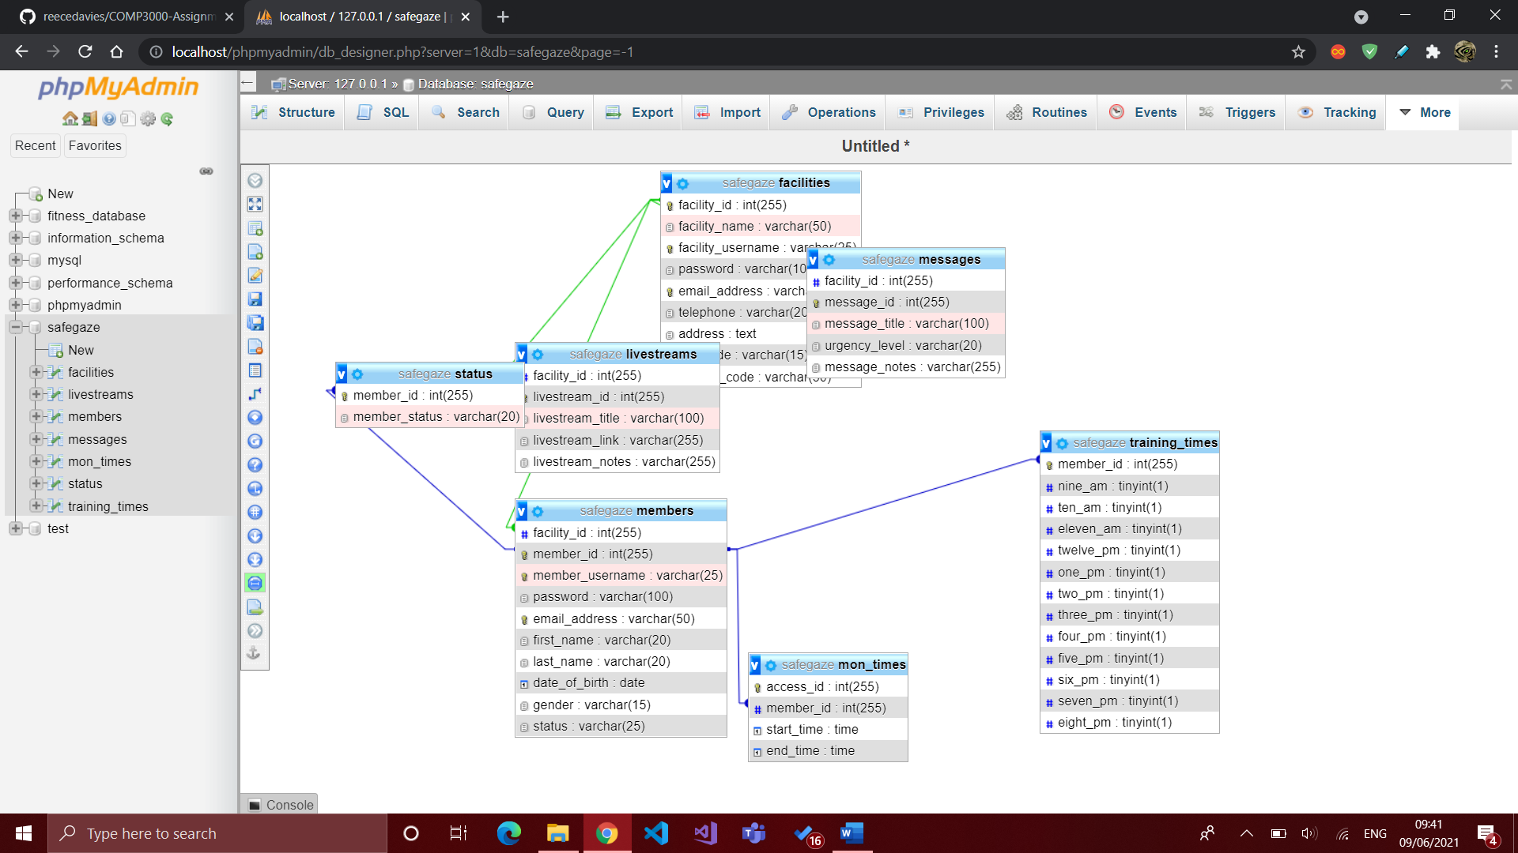

## Adding data

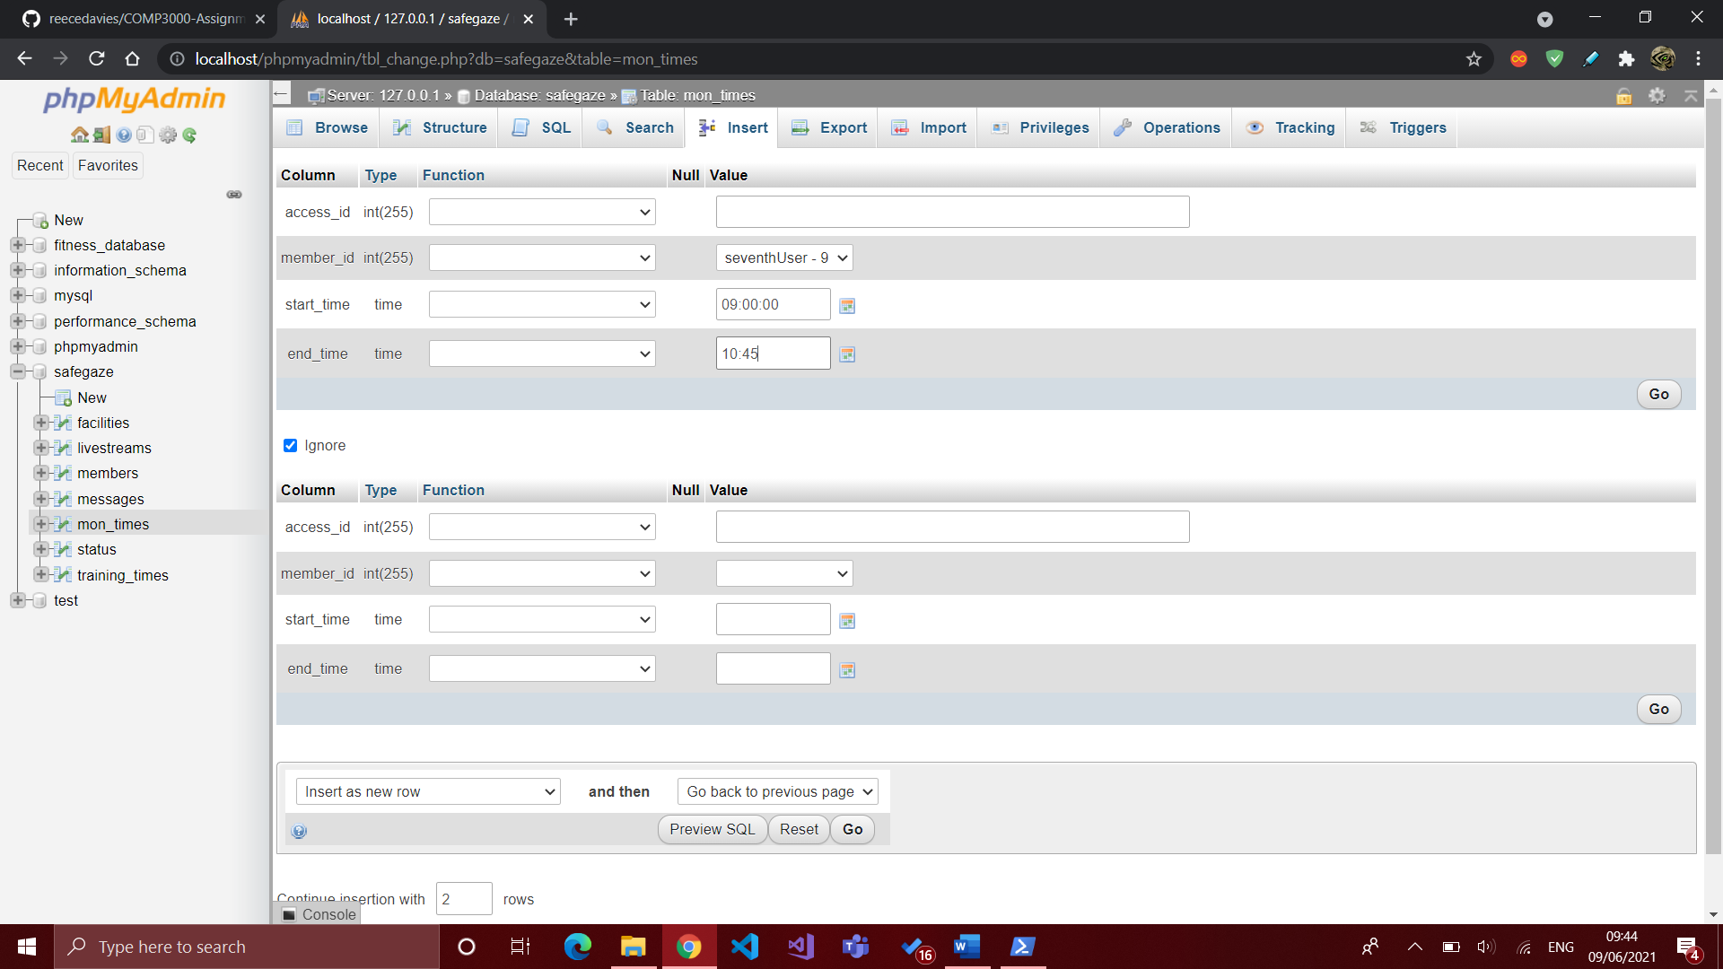

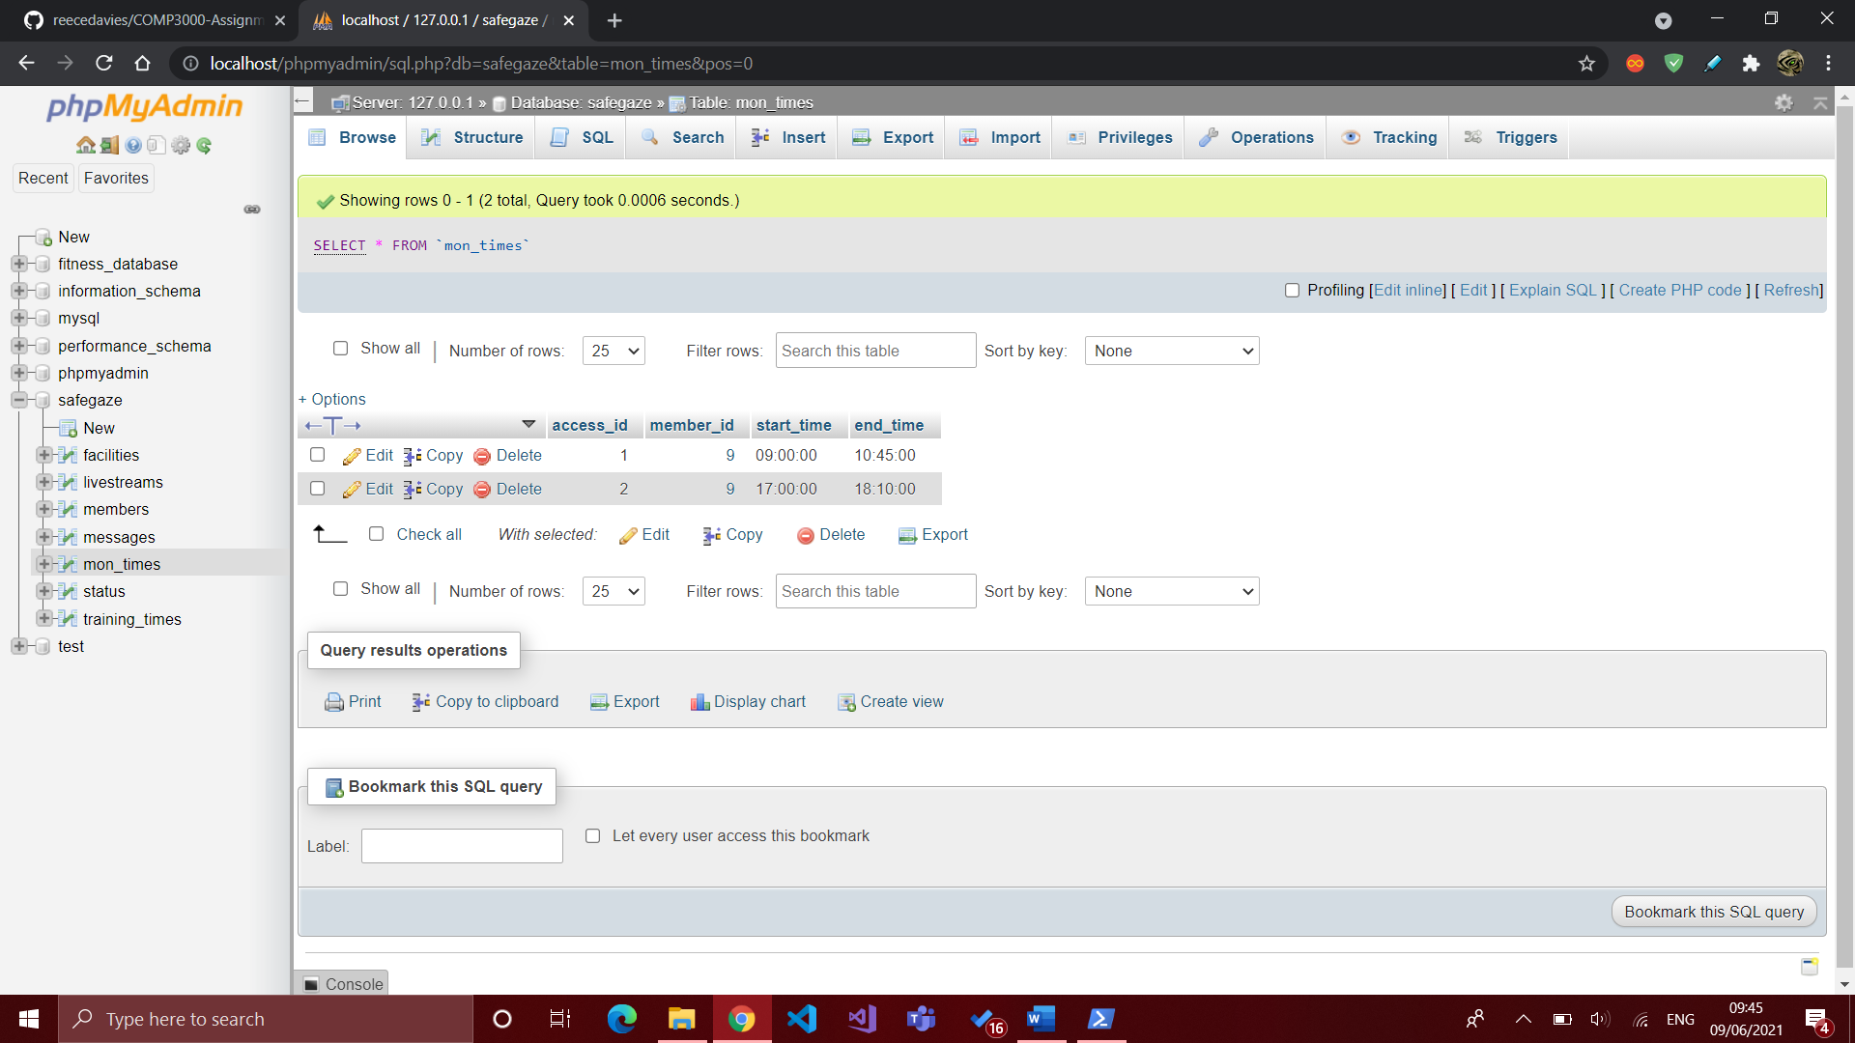

## New DB ERD screenshot

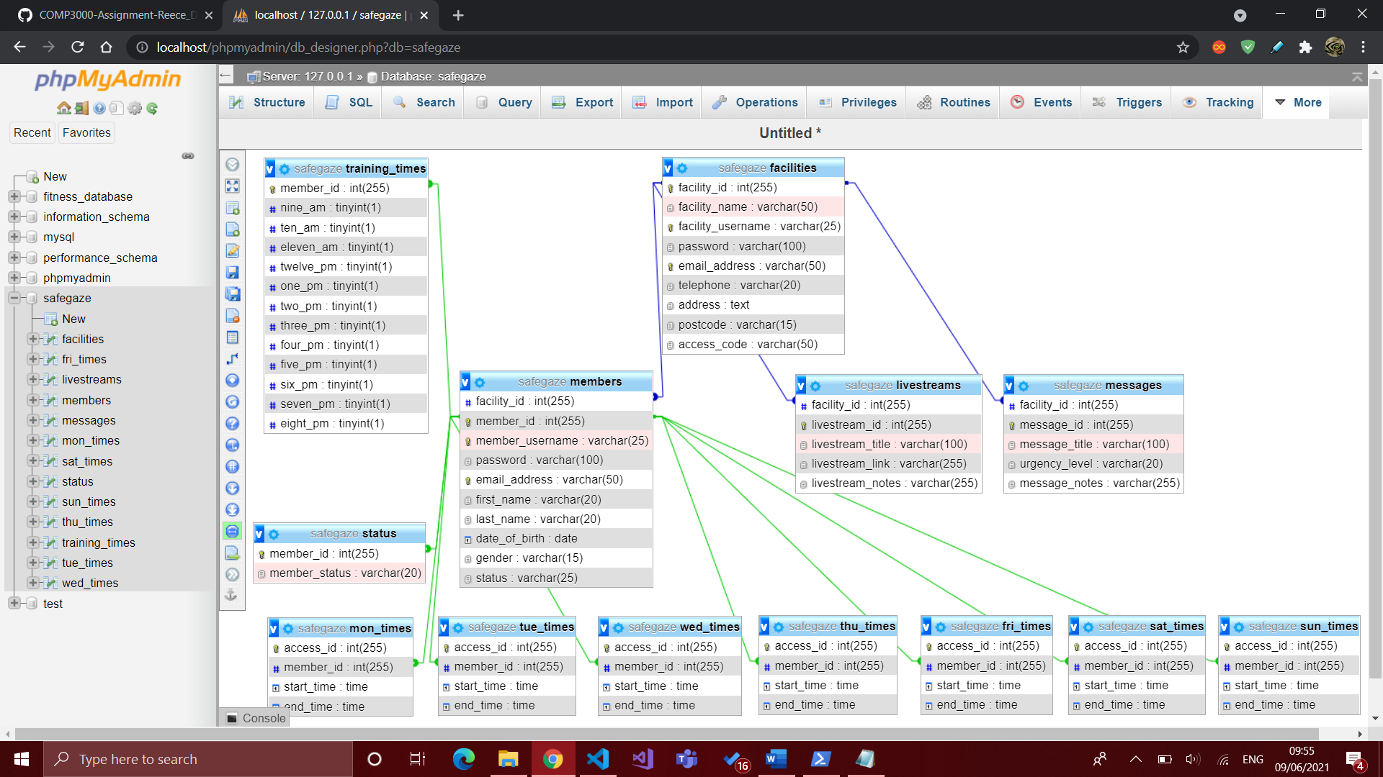

## Listing access times (manage member)

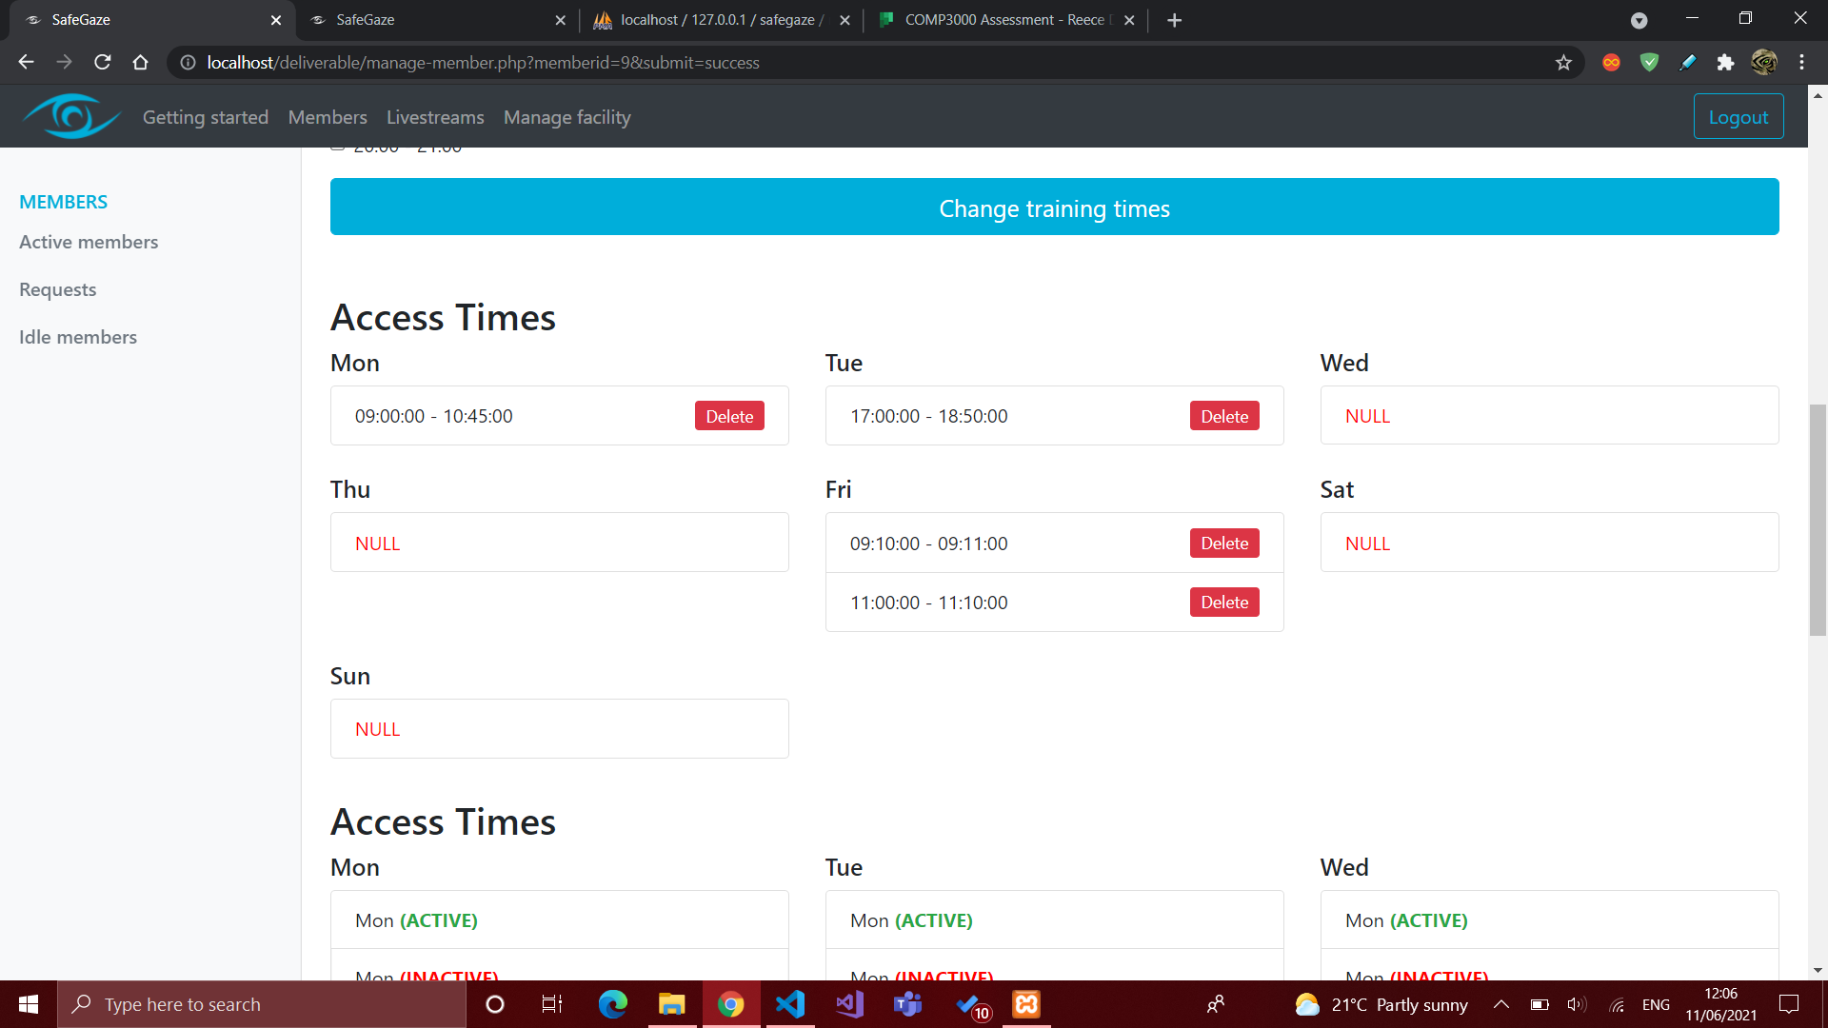

## Changing access times (manage member)

Initial draft

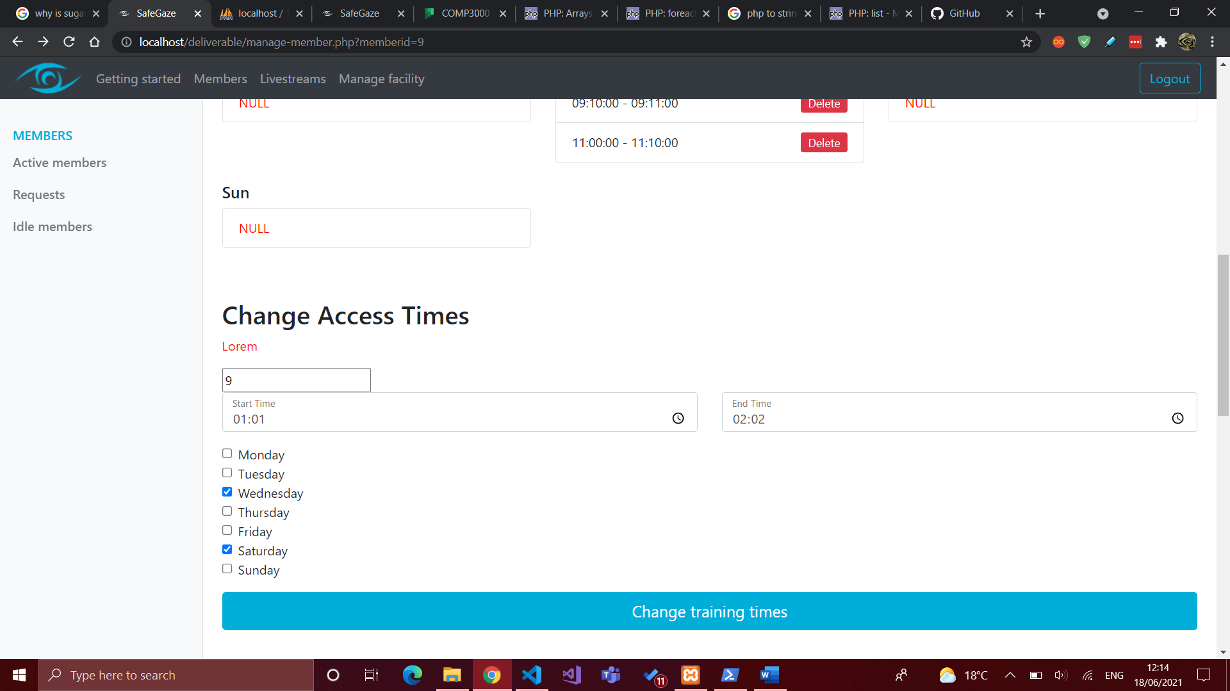

After refining

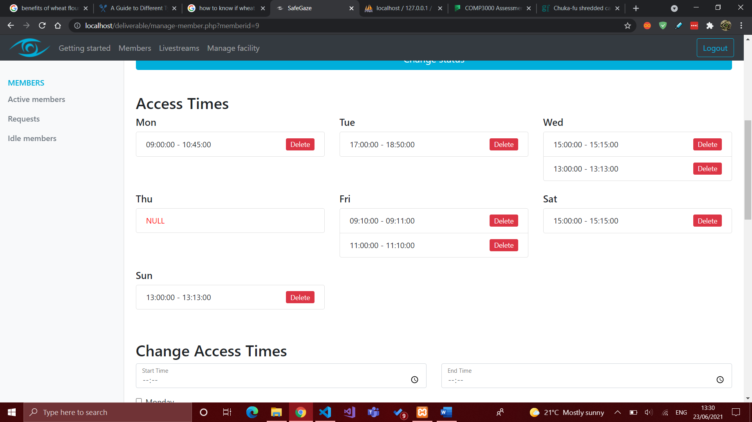

## Listing access times (member livestream)

First draft. The form button needs to be removed

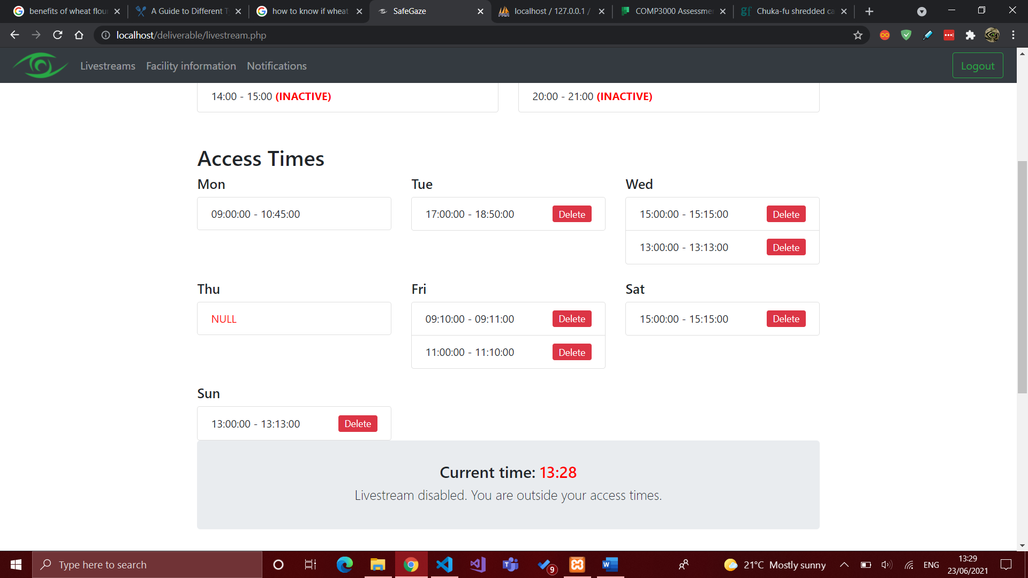

After refinement

